

ASSET VERIFICATION AND RECORDING TOOL KIT


Plot 31, Bukoto Street
P.O Box 7657, Kampala, Uganda
+256 (0) 39 2000216/0772525235
email: cpa@cpa.ug

www.cpa.com

August to September 2026

VERIFICATION DETAILS

NAME OF THE REGION: | WESTERN
SUB-REGION: | TOORO
Name of Local Government | KYEGEGWA DISTRICT
VERIFIER PARTICULARS
Full name | KATO CHARLES
Contact/ email and Telephone | 0755790124 & katoc560@gmail.com
Supervisor/ Sub team leader
Name | Prof: MBONIGABA DEPAUL
Contact | 0788483159
Date of submission | 31/08/2026

HEALTH CENTRES
INFORMANT INTERVIEW/DISCUSSION GUIDE (INCHARGE OR RESPONSIBLE PERSON)

Name of Health Centre: KABWEZA HC III

1a | Does the Facility have a record of all assets provided under UgIFT.  (Obtain a record and verify if it has the costs and numbers supplied | The facility had a book for assets though it wasn’t clear.
1b | If not ask how many were supplied and when.

2 | How does this facility Maintain (repair/service/replace) the assets provided under Ugift

Minor repairs are done using dedicated budget line on PHC grant and major repairs or replacements are written off in the inventory book and are reported to the district health office, however the facility has not done any repairs in the past.

3 | Does the facility take regular record about functionality/ or breakdown of the assets provided? | Yes, the facility had a list of the items available

The facility collects and records broken/spoilt equipment regularly and are taken to the district from where they are repaired by the teams from fort portal regional referral hospital

4 | How has the UgIFT support helped in service delivery in the area, any issues, challenges and any recommendations for better program implementation.

The UGIFT program supported the construction of the entire health unity and provided all the necessary infrastructure which eased service delivery in the kabweza community evidenced by high turn up of mother for immunization. However, some equipment depreciated very quickly, others had a short life span, for example the office chairs that were provided got broken.
He also recommended that health facilities be involved in the procurement of these items such that they are not oversupplied with a particular equipment

PROCEED TO VERIFICATION AFTER THIS DISCUSSION

Health centre checklist

NAME OF LG: KYEGEGWA DISTRICT NAME OF HEALTH FACILITY: KABWEZA HC III

Equipment/ Item | Department | Asset Number | Item  Description | Life in Months | Tag Number (engrave no.) | Date Of Purchase | Date Placed in Service | Recoverable cost | Cost | Acc Dep Cost | Net Book Value | Ytd Deprn | Equipment status | Remarks
B.P. Machine, Digital | health |  | Sionocare BP machine |  | Not engraved |  | 8/05/2024 |  |  |  |  |  | 4 functional and one in the store | 1 BP machine in the store
 | Health |  | Sinocare bp machine |  | Not engraved |  | 8/05/2024 |  |  |  |  |  | functional | 1 BP machine in the store
 | Health |  | Sinocare bp machine |  | Not engraved |  | 8/05/2024 |  |  |  |  |  | functional | 1 BP machine in the store
 | Health |  | Sinocare bp machine |  | Not engraved |  | 8/05/2024 |  |  |  |  |  | functional | 1 BP machine in the store
B.P. Machine (Aneroid wall mounted) | health |  | BP machine (aneroid wall mounted, Navy blue in colour |  | Not engraved |  | 8/05/2024 |  |  |  |  |  | Not functional
 | health |  | BP machine (aneroid wall mounted, Navy blue in colour |  | Not engraved |  | 8/05/2024 |  |  |  |  |  | Notfunctional
Autoclave 20 Liters., Duo Operated | health |  | Autoclave, external heated, 20liters |  | Not engraved |  | 8/05/2024 |  |  |  |  |  | functional
Bowl, Kick | Health |  | 1 bowl kick |  | Not engraved |  | 8/05/2024 |  |  |  |  |  | functional
Bowl Stand | Health |  | Stainless steel movable |  | Not engraved |  | 8/05/2024 |  |  |  |  |  | functional
 | health |  | Stainless steel movable |  | Not engraved |  | 8/05/2024 |  |  |  |  |  | functional
Counting chamber Neubauer- Improved | Health
 | health |  | Rectangular shaped apparatus with droppers |  | Not engraved |  | 8/05/2024 |  |  |  |  |  | Functional | 1 in the lab
 | Health |  | Rectangular shaped apparatus with droppers |  |  |  | 8/05/2024 |  |  |  |  |  | Not functional | 1 in the lab
Cupboard Steel, Lockable
 | Health |  | 1 cupboard steel with transparent glass, lockable (grey) |  | Not |  | 8/05/2024 |  |  |  |  |  | Functional | The facility had 7 cupboards steel
 | Health |  | 1 cupboard steel with transparent glass, lockable (grey) |  | Not |  | 8/05/2024 |  |  |  |  |  | functional | The facility had 7 cupboards steel
 | Health |  | 1 cupboard steel with transparent glass, lockable (grey) |  | Not |  | 8/05/2024 |  |  |  |  |  | functional | The facility had 7 cupboards steel
 | Health |  | 1 cupboard steel with transparent glass, lockable (grey) |  | Not |  | 8/05/2024 |  |  |  |  |  | Functional | The facility had 7 cupboards steel
 | Health |  | 1 cupboard steel with transparent glass, lockable (grey) |  | Not |  | 8/05/2024 |  |  |  |  |  | functional | The facility had 7 cupboards steel
 | Health |  | 1 cupboard steel with transparent glass, lockable (grey) |  | Not |  | 8/05/2024 |  |  |  |  |  | functional | The facility had 7 cupboards steel
 | Health |  | 1 cupboard steel with transparent glass, lockable (grey) |  | Not |  | 8/05/2024 |  |  |  |  |  | functional | The facility had 7 cupboards steel
Drip Stand
 | Health |  | 1 Drip stand, stainless steel |  | Not engraved |  | 8/05/2024 |  |  |  |  |  | Not functional | The facility received 5 drip stands
 | Health |  | 1Drip stand, |  | Not engraved |  | 8/05/2024 |  |  |  |  |  | Not functional | The facility received 5 drip stands
 | Health |  | Drip stand |  | Not engraved |  | 8/05/2024 |  |  |  |  |  | Not functional | The facility received 5 drip stands
 | Health |  | Drip stand, |  | Not engraved |  | 8/05/2024 |  |  |  |  |  | Not functional | The facility received 5 drip stands
 | Health |  | Drip stand, |  | Not engraved |  | 8/05/2024 |  |  |  |  |  | Not functional | The facility received 5 drip stands
ESR Stand
 | health |  | 1 ESR was available with sedimentation tubes |  | Not engraved |  | 8/05/2024 |  |  |  |  |  | functional
Examination Couch
 | Health |  | Examination couch metallic with a mattress |  | Not engraved |  | 8/05/2024 |  |  |  |  |  | functional
 | Health |  | Examination couch metallic with a mattress |  | Not engraved |  | 8/05/2024 |  |  |  |  |  | functional
 | Health |  | Examination couch metallic with a mattress |  | Not engraved |  | 8/05/2024 |  |  |  |  |  | functional
 | Health |  | Examination couch metallic with a mattress |  | Not engraved |  | 8/05/2024 |  |  |  |  |  | functional
Examination light, LED
 | Health |  | LED examination light |  | Not engraved |  | 8/05/2024 |  |  |  |  |  | functional
 | Health |  | LED examination light |  | Not engraved |  | 8/05/2024 |  |  |  |  |  | functional
Glucometer | health |  |  |  |  |  |  |  |  |  |  |  |  | Items in the store
 | health |  | A Yuwell glucometer, SN: B25070000104 |  | NOT ENGRAVED |  | 8/05/2024 |  |  |  |  |  | Not functional | Items in the store
 |  |  | A Yuwell glucometer, SN: B25070000104 |  | NOT ENGRAVED |  | 8/05/2024 |  |  |  |  |  | Not functional | Items in the store
Haemoglobin Meter, Digital | health |  |  |  |  |  | 8/05/2024
 | Health |  | Haemoglobin Meter, Digital |  | Not engraved |  | 8/05/2024 |  |  |  |  |  | Not functional
 | Health |  | Haemoglobin Meter, Digital |  | Not engraved |  | 8/05/2024 |  |  |  |  |  | Not functional
Height Meter
 | Health |  | 1 height meter |  | Not engraved |  | 8/05/2024 |  |  |  |  |  | Functional
Instrument Trolley
 | health |  | 1 instrument trolly |  | Not engraved |  | 8/05/2024 |  |  |  |  |  | Functional
 | health |  | 1 instrument trolly |  | Not engraved |  | 8/05/2024 |  |  |  |  |  | Functional
Microscope Binocular | health |  | 1 microscope binocular, (MEDMAY, MMIC204) MICROSCOPE |  | Not engraved |  | 8/05/2024 |  |  |  |  |  | Functional
 |  |  |  |  |  |  | 8/05/2024
 |  |  |  |  |  |  | 8/05/2024
Otoscope | health
 |  |  | 1 otoscope |  | Not engraved |  | 8/05/2024 |  |  |  |  |  | Functional
Patient Screen | health
 | health |  | 1 patient screen, super care model TS-19 |  | Not engraved |  | 8/05/2024 |  |  |  |  |  | Not functional
 | health |  | 1 patient screen, metallic, blue in colour, movable |  | Not engraved |  | 8/05/2024 |  |  |  |  |  | Not functional
 | health |  | 1 patient screen |  | Not engraved |  | 8/05/2024 |  |  |  |  |  | Not functional
 | health |  | 1 patient screen, super care model |  | Not engraved |  | 8/05/2024 |  |  |  |  |  | Not functional
 | health |  | 1 patient screen, metallic, blue in colour, movable |  | Not engraved |  | 8/05/2024 |  |  |  |  |  | Not functional
 | health |  | 1 patient screen, metallic, blue in colour, movable |  | Not engraved |  | 8/05/2024 |  |  |  |  |  | Not functional
Patient Trolley | Health |  | 1 patient trolley of casp |  |  |  | 8/05/2024 |  |  |  |  |  | functional
Refrigerator, Basic | Health |  | 1 refrigerator (GENERAL), | 18 months | Not engraved |  | 8/05/2024 |  |  |  |  |  | Not functional
Stethoscope | Health |  | stethoscope |  | Not engraved |  | 8/05/2024 |  |  |  |  |  | Functional
 | Health |  | stethoscope |  | Not engraved |  | 8/05/2024 |  |  |  |  |  | Not functional
 | Health |  | stethoscope |  | Not engraved |  | 8/05/2024 |  |  |  |  |  | Not functional
 | Health |  | stethoscope |  | Not engraved |  | 8/05/2024 |  |  |  |  |  | Not functional
Stop Watch |  |  |  |  |  |  | 8/05/2024
 | HEALTH |  | 1 stopwatch |  | Not engraved |  | 8/05/2024 |  |  |  |  |  | Functional
Stretcher |  |  |  |  |  |  | 8/05/2024
 | Health |  | 1 ambulance stretcher, movable sn: CM002 |  | Not engraved |  | 8/05/2024 |  |  |  |  |  | Functional
Stove, Gas | health |  | STOVE GAS |  | Not engraved |  | 8/05/2024 |  |  |  |  |  | Functional
 |  |  |  |  |  |  | 8/05/2024
Weighing Scale with Height Meter, Adult
 | Health |  | 1 weighing scale with height measure |  | Not engraved |  | 8/05/2024 |  |  |  |  |  | functional
 | health |  | 1 weighing scale with height measure |  | Not engraved |  | 8/05/2024 |  |  |  |  |  | Functional
Weighing Scale, Infant | Health |  | Hanging weighing scale foe infants, SN: BS-50 |  | Not engraved |  | 8/05/2024 |  |  |  |  |  | functional
 | Health |  | Hanging weighing scale foe infants, SN: BS-50 |  | NOT ENGRAVED |  | 8/05/2024 |  |  |  |  |  | NOT FUNCTIONAL
Weighing Scale, Toddler | Health |  | 1 weighing scale toddler, KUANYI MODEL, BS-50 |  | Not engraved |  | 8/05/2024 |  |  |  |  |  | Functional in the maternity ward
 | Health |  | 1 weighing scale toddler, KUANYI MODEL, BS-50 |  | Not engraved |  | 8/05/2024 |  |  |  |  |  | Functional in the maternity ward
Wheelchair | Health |  | 1 wheelchair |  | Not engraved |  | 8/05/2024 |  |  |  |  |  | functional | 2 Items in the store
 | Health |  | 1 wheelchair |  | Not engraved |  | 8/05/2024 |  |  |  |  |  | Not functional | 2 Items in the store
 | Health |  | 1 wheelchair |  | Not engraved |  | 8/05/2024 |  |  |  |  |  | Not functional | 2 Items in the store
Audio Visual Equipment
 | Health |  | 1 flat screen TV |  | Not engraved |  | 8/05/2024 |  |  |  |  |  | functional
Medical Waste Bin | health
 | Health |  | Stainless steel bins |  | Not engraved |  | 8/05/2024 |  |  |  |  |  | Functional
 | Health |  | Stainless steel bins |  | Not engraved |  | 8/05/2024 |  |  |  |  |  | Functional
 | Health |  | Medical waste bins |  | Not engraved |  | 8/05/2024 |  |  |  |  |  | Functional
 | Health |  | Medical waste bins |  | Not engraved |  | 8/05/2024 |  |  |  |  |  | Functional
 | Health |  | Medical waste bins |  | Not engraved |  | 8/05/2024 |  |  |  |  |  | functional
Wall Clock
 | Health |  | Wall clock |  | Not engraved |  | 8/05/2024 |  |  |  |  |  | functional
 | Health |  | Wall clock |  | Not engraved |  | 8/05/2024 |  |  |  |  |  | functional
 | Health |  | Wall clock |  | Not engraved |  | 8/05/2024 |  |  |  |  |  | Functional
Diagnostic Equipment Set for MCH | Health | SL304 | Full diagnostic set consisting of all equipment (full medical package) |  | Not engraved |  | 8/05/2024 |  |  |  |  |  | Not functional
 | Health | SL304 | Full diagnostic set consisting of all equipment (full medical package) |  | NOT ENGRAVED |  | 8/05/2024 |  |  |  |  |  | NOT FUNCTIONAL
 | Health | SL304 | Full diagnostic set consisting of all equipment (full medical package) |  | NOT ENGRAVED |  | 8/05/2024 |  |  |  |  |  | NOT FUNCTIONAL
Diagnostic Equipment Set for OPD
 | Health | SL304 | 1 diagnostic equipment set |  | Not engraved |  | 8/05/2024 |  |  |  |  |  | Not Functional | The items were available but couldn’t be verified because one staff with the keys was on leave
 | Health | SL304 | 1 diagnostic equipment set |  | Not engraved |  | 8/05/2024 |  |  |  |  |  | Not functional
 | Health | SL304 | 1 diagnostic equipment set |  | Not engraved |  | 8/05/2024 |  |  |  |  |  | Not functional
Glassware Set, Laboratory, Basic
 | Health |  | 1 glass ware set` |  | Not engraved |  | 8/05/2024 |  |  |  |  |  | Functional
 | Health |  | 1 glass ware set` |  | Not engraved |  | 8/05/2024 |  |  |  |  |  | Functional
 | Health |  | 1 glass ware set` |  | Not engraved |  | 8/05/2024 |  |  |  |  |  | Functional
Hollow Ware Set, Treatment
 | Health |  | 1 hollow ware set, full set |  | Not engraved |  | 8/05/2024 |  |  |  |  |  | Not functional
 | Health | SL304 | 1 hollow ware set, full set |  | Not engraved |  | 8/05/2024 |  |  |  |  |  | Not functional
 | Health |  | 1 hollow ware set, full set |  | Not engraved |  | 8/05/2024 |  |  |  |  |  | Not functional
Instrument Set, Dressing
 | Health | SL304 | 1 Set consists of forceps, scissors, bowls, lotion, kidney, instrument container s/s with cover. |  | Not engraved |  | 8/05/2024 |  |  |  |  |  | Functional
 | Health | SL304 | 1 Set consists of forceps, scissors, bowls, lotion, kidney, instrument container s/s with cover |  | Not engraved |  | 8/05/2024 |  |  |  |  |  | Not functional | Health
 | Health | SL304 | 1 Set consists of forceps, scissors, bowls, lotion, kidney, instrument container s/s with cover |  | Not engraved |  | 8/05/2024 |  |  |  |  |  | Not functional | Health
Instrument Set, Basic ENT
 | Health | SL304 | 1 Set consists of forceps, scissors, bowls, lotion, kidney, instrument container s/s with cover. |  | Not engraved |  | 8/05/2024 |  |  |  |  |  | Functional
Instrument Set, Suture | Health | SL304 | 1 Set consists of forceps, scissors, bowls, lotion, kidney, instrument container s/s with cover. |  | Not engraved |  | 8/05/2024 |  |  |  |  |  | Functional
 | Health | SL304 | 1 Set consists of forceps, scissors, bowls, lotion, kidney, instrument container s/s with cover. |  | Not engraved |  | 8/05/2024 |  |  |  |  |  | Functional
Pulse Oximeter, Handheld
 | Health |  | 1 Pulse oximeter, handheld |  | Not engraved |  | 8/05/2024 |  |  |  |  |  | Functional
 | Health |  | 1 Pulse oximeter, handheld |  | Not engraved |  | 8/05/2024 |  |  |  |  |  | Not functional
Bed, Adult Patient with Mattress | Health |  | Adult beds with metallic mattresses, model B11 batch no 20220542 |  | Not engraved |  | 8/05/2024 |  |  |  |  |  | functional | The facility received 20 making their total 26 beds which were too many, and 2 are stored in the male ward due to limited storage space, and 8 bed are being used by staff members
 | Health |  | Adult beds with metallic mattresses, model B11 batch no 20220542 |  | Not engraved |  | 8/05/2024 |  |  |  |  |  | Functional
 | Health |  | Adult beds with metallic mattresses, model B11 batch no 20220542 |  | Not engraved |  | 8/05/2024 |  |  |  |  |  | Functional
 | Health |  | Adult beds with metallic mattresses, model B11 batch no 20220542 |  |  |  | 8/05/2024 |  |  |  |  |  | Functional
 | Health |  | Adult beds with metallic mattresses, model B11 batch no 20220542 |  | Not engraved |  | 8/05/2024 |  |  |  |  |  | Functional
 | Health |  | Adult beds with metallic mattresses, model B11 batch no 20220542 |  | Not engraved |  | 8/05/2024 |  |  |  |  |  | Functional
 | Health |  | Adult beds with metallic mattresses, model B11 batch no 20220542 |  | Not engraved |  | 8/05/2024 |  |  |  |  |  | Functional
 | Health |  | Adult beds with metallic mattresses, model B11 batch no 20220542 |  | Not engraved |  | 8/05/2024 |  |  |  |  |  | Functional
 | Health |  | Adult beds with metallic mattresses, model B11 batch no 20220542 |  | Not engraved |  | 8/05/2024 |  |  |  |  |  | Functional
 | Health |  | Adult beds with metallic mattresses, model B11 batch no 20220542 |  | Not engraved |  | 8/05/2024 |  |  |  |  |  | Functional
Bed, Pediatric Patient, With Mattress
 | Health |  | Pediatric beds with metallic mattresses |  | Not engraved |  | 8/05/2024 |  |  |  |  |  | Functional
 | Health |  | pediatrics beds with mattresses metallic |  | Not engraved |  | 8/05/2024 |  |  |  |  |  | Functional
 | Health |  | pediatrics beds with mattresses metallic |  | Not engraved |  | 8/05/2024 |  |  |  |  |  | Functional
 | Health |  | pediatric beds with mattresses metallic |  | Not engraved |  | 8/05/2024 |  |  |  |  |  | Functional
 | Health |  | pediatrics beds with mattresses metallic |  | Not engraved |  | 8/05/2024 |  |  |  |  |  | Functional
 | Health |  | Pediatric beds with metallic mattresses |  | Not engraved |  | 8/05/2024 |  |  |  |  |  | Functional
 | Health |  | pediatrics beds with mattresses metallic |  | Not engraved |  | 8/05/2024 |  |  |  |  |  | Not Functional | 4 beds are still in the store
 | Health |  | pediatrics beds with mattresses metallic |  | Not engraved |  | 8/05/2024 |  |  |  |  |  | Not Functional | 4 beds are still in the store
 | Health |  | pediatric beds with mattresses metallic |  | Not engraved |  | 8/05/2024 |  |  |  |  |  | Not Functional | 4 beds are still in the store
 | Health |  | Pediatric beds with metallic mattresses |  | Not engraved |  | 8/05/2024 |  |  |  |  |  | Not Functional | 4 beds are still in the store
Bedside Locker
 | health |  | Metallic bedside lockers, steel |  | Not engraved |  | 8/05/2024 |  |  |  |  |  | functional
 | Health |  | Metallic bedside lockers, steel |  | Not engraved |  | 8/05/2024 |  |  |  |  |  | Functional
 | Health |  | Metallic bedside lockers, steel |  | Not engraved |  | 8/05/2024 |  |  |  |  |  | Functional
 | Health |  | Metallic bedside lockers, steel |  | Not engraved |  | 8/05/2024 |  |  |  |  |  | Functional
 | Health |  | Metallic bedside lockers, steel |  | Not engraved |  | 8/05/2024 |  |  |  |  |  | Functional
 | Health |  | Metallic bedside lockers, steel |  | Not engraved |  | 8/05/2024 |  |  |  |  |  | Functional
 | Health |  | Metallic bedside lockers, steel |  | Not engraved |  | 8/05/2024 |  |  |  |  |  | Functional
 | Health |  | Metallic bedside lockers, steel |  | Not engraved |  | 8/05/2024 |  |  |  |  |  | Functional
 | Health |  | Metallic bedside lockers, steel |  | Not engraved |  | 8/05/2024 |  |  |  |  |  | Functional
 | Health |  | Metallic bedside lockers, steel |  | Not engraved |  | 8/05/2024 |  |  |  |  |  | Functional
 | Health |  | Metallic bedside lockers, steel |  | Not engraved |  | 8/05/2024 |  |  |  |  |  | Functional
Cupboard, Instrument
 |  |  | 1 cupboard steel lockable |  | Not engraved |  | 8/05/2024 |  |  |  |  |  | functional
Delivery Bed, Hydraulic Manual | health |  | 1 Delivery bed manual hydraulic |  | Not engraved |  | 8/05/2024 |  |  |  |  |  | Functional
 | health |  | 1 Delivery bed manual hydraulic |  | Not engraved |  | 8/05/2024 |  |  |  |  |  | functional
Oxygen Therapy Apparatus, Minimum 45L cylinder | Health |  | 1 Oxygen cylinders of 49,8L 2, oxygen regulators (2), humidifier bottles (2) |  | Not engraved |  | 8/05/2024 |  |  |  |  |  | Not functional
 | Health |  | 1 Oxygen cylinders of 49,8L 2, oxygen regulators (2), humidifier bottles (2) |  | Not engraved |  | 8/05/2024 |  |  |  |  |  | Not functional
 | Health |  | 1 Oxygen cylinders of 49,8L 2, oxygen regulators (2), humidifier bottles (2) |  | Not engraved |  | 8/05/2024 |  |  |  |  |  | Not functional
 | Health |  | 1 Oxygen cylinders of 49,8L 2, oxygen regulators (2), humidifier bottles (2) |  | Not engraved |  | 8/05/2024 |  |  |  |  |  | Not functional
 | Health |  | 1 Oxygen cylinders of 49,8L 2, oxygen regulators (2), humidifier bottles (2) |  | Not engraved |  | 8/05/2024 |  |  |  |  |  | Not functional
Resuscitator Manual, Infant, with all Mask sizes | Health |  | 1 resuscitator ,manual |  | Not engraved |  | 8/05/2024 |  |  |  |  |  | Not functional
 | Health |  | 1 resuscitator, manual |  | Not engraved |  | 8/05/2024 |  |  |  |  |  | Not functional
 | Health |  | 1 resuscitator, manual |  | Not engraved |  | 8/05/2024 |  |  |  |  |  | Not functional
 | Health |  | 1 resuscitator, manual |  | Not engraved |  | 8/05/2024 |  |  |  |  |  | Not functional
 | Health |  | 1 resuscitator, manual |  | Not engraved |  | 8/05/2024 |  |  |  |  |  | Not functional
 | Health |  | 1 resuscitator, manual |  | Not engraved |  | 8/05/2024 |  |  |  |  |  | Not functional
 | Health |  | 1 resuscitator, manual |  | Not engraved |  | 8/05/2024 |  |  |  |  |  | Not functional
 | Health |  | 1 resuscitator, manual |  | Not engraved |  | 8/05/2024 |  |  |  |  |  | Not functional
 | Health |  | 1 resuscitator, manual |  | Not engraved |  | 8/05/2024 |  |  |  |  |  | Not functional
 | Health |  | 1 resuscitator, manual |  | Not engraved |  | 8/05/2024 |  |  |  |  |  | Not functional
 | Health |  | 1 resuscitator, manual |  | Not engraved |  | 8/05/2024 |  |  |  |  |  | Not functional
 | Health |  | 1 resuscitator, manual |  | Not engraved |  | 8/05/2024 |  |  |  |  |  | Not functional
Resuscitator Manual, Adult, with all mask sizes | Health |  | 1 resuscitator manual, adult |  | Not engraved |  | 8/05/2024 |  |  |  |  |  | Not functional | The resuscitators were in the store
 | Health |  | 1 resuscitator manual, adult |  | Not engraved |  | 8/05/2024 |  |  |  |  |  | Not functional | The resuscitators were in the store
 | Health |  | 1 resuscitator manual, adult |  | Not engraved |  | 8/05/2024 |  |  |  |  |  | Not functional | The resuscitators were in the store
 | Health |  | 1 resuscitator manual, adult |  | Not engraved |  | 8/05/2024 |  |  |  |  |  | Not functional | The resuscitators were in the store
 | Health |  | 1 resuscitator manual, adult |  | Not engraved |  | 8/05/2024 |  |  |  |  |  | Not functional | The resuscitators were in the store
 | Health |  | 1 resuscitator manual, adult |  | Not engraved |  | 8/05/2024 |  |  |  |  |  | Not functional | The resuscitators were in the store
 | Health |  | 1 resuscitator manual, adult |  | Not engraved |  | 8/05/2024 |  |  |  |  |  | Not functional | The resuscitators were in the store
 | Health |  | 1 resuscitator manual, adult |  | Not engraved |  | 8/05/2024 |  |  |  |  |  | Not functional | The resuscitators were in the store
 | Health |  | 1 resuscitator manual, adult |  | Not engraved |  | 8/05/2024 |  |  |  |  |  | Not functional | The resuscitators were in the store
 | Health |  | 1 resuscitator manual, adult |  | Not engraved |  | 8/05/2024 |  |  |  |  |  | Not functional | The resuscitators were in the store
 | Health |  | 1 resuscitator manual, adult |  | Not engraved |  | 8/05/2024 |  |  |  |  |  | Not functional | The resuscitators were in the store
 | Health |  | 1 resuscitator manual, adult |  | Not engraved |  | 8/05/2024 |  |  |  |  |  | Not functional | The resuscitators were in the store
 | Health |  | 1 resuscitator manual, adult |  | Not engraved |  | 8/05/2024 |  |  |  |  |  | Not functional | The resuscitators were in the store
 | Health |  | 1 resuscitator manual, adult |  | Not engraved |  | 8/05/2024 |  |  |  |  |  | Not functional | The resuscitators were in the store
Suction Apparatus, (Electric)
 | Health |  | 1 suction apparatus, electric |  | Not engraved |  | 8/05/2024 |  |  |  |  |  | Not functional
 | Health |  | 1 suction apparatus, electric |  | Not engraved |  | 8/05/2024 |  |  |  |  |  | Not functional
 | Health |  | 1 suction apparatus, electric |  | Not engraved |  | 8/05/2024 |  |  |  |  |  | Not functional
Nebulizer, Ultrasonic
 | Health |  | 1 nebulizer ultrasonic |  | Not engraved |  | 8/05/2024 |  |  |  |  |  | Not functional
Oxygen Concentrator, Duo Flow
 | Health |  | 1 Oxygen concentrator |  | not |  | 8/05/2024 |  |  |  |  |  | functional
 | Health |  | 1 Oxygen concentrator |  | not |  | 8/05/2024 |  |  |  |  |  | functional
 | Health |  | 1Oxygen concentrator |  | not |  | 8/05/2024 |  |  |  |  |  | functional
 | Health |  | 1Oxygen concentrator |  | not |  | 8/05/2024 |  |  |  |  |  | functional
Bench
 | Health |  | 1 metallic vanished bench |  |  |  | 8/05/2024 |  |  |  |  |  | functional
 | Health |  | 1 metallic vanished bench |  |  |  | 8/05/2024 |  |  |  |  |  | functional
 | Health |  | 1 metallic vanished bench |  |  |  | 8/05/2024 |  |  |  |  |  | functional
 | Health |  | 1 metallic vanished bench |  | Not engraved |  | 8/05/2024 |  |  |  |  |  | functional
Disinfection Buckets |  |  |  |  |  |  | 8/05/2024
 | Health |  | 1 disinfection bucket |  | Not engraved |  | 8/05/2024 |  |  |  |  |  | functional
 | Health |  | 1 disinfection bucket |  | Not engraved |  | 8/05/2024 |  |  |  |  |  | functional
 | Health |  | 1 disinfection bucket |  | Not engraved |  | 8/05/2024 |  |  |  |  |  | functional
 | Health |  | 1 disinfection bucket |  | Not engraved |  | 8/05/2024 |  |  |  |  |  | functional
 | Health |  | 1 disinfection bucket |  | Not engraved |  | 8/05/2024 |  |  |  |  |  | functional
 | Health |  | 1 disinfection bucket |  | Not engraved |  | 8/05/2024 |  |  |  |  |  | functional
Baby Cot
 | Health |  | 1 baby cot |  | Not engraved |  | 8/05/2024 |  |  |  |  |  | functional
 | Health |  | 1 baby cot |  | Not engraved |  | 8/05/2024 |  |  |  |  |  | functional
 | Health |  | 1 baby cot |  | Not engraved |  | 8/05/2024 |  |  |  |  |  | Not functional
 | Health |  | 1 baby cot |  | Not engraved |  | 8/05/2024 |  |  |  |  |  | Not functional
 | Health |  | 1 baby cot |  | Not engraved |  | 8/05/2024 |  |  |  |  |  | Not functional
Diagnostic Equipment Set for Ward
 | health |  | 1 Set consists of:  Depressor, tongue, metal, hammer, percussion, reflex test, solid rubber head, ophthalmoscope, aneroid cuffs, stethoscope, tape, measure, cloth, thermometers, tuning forks, proctoscope, and syringes |  | Not engraved |  | 8/05/2024 |  |  |  |  |  | Functional
 | health |  | 1 Set consists of:  Depressor, tongue, metal, hammer, percussion, reflex test, solid rubber head, ophthalmoscope, aneroid cuffs, stethoscope, tape, measure, cloth, thermometers, tuning forks, proctoscope, and syringes |  | Not engraved |  | 8/05/2024 |  |  |  |  |  | Functional
 | health |  | 1 Set consists of:  Depressor, tongue, metal, hammer, percussion, reflex test, solid rubber head, ophthalmoscope, aneroid cuffs, stethoscope, tape, measure, cloth, thermometers, tuning forks, proctoscope, and syringes |  | Not engraved |  | 8/05/2024 |  |  |  |  |  | Functional
 | health |  | 1 Set consists of:  Depressor, tongue, metal, hammer, percussion, reflex test, solid rubber head, ophthalmoscope, aneroid cuffs, stethoscope, tape, measure, cloth, thermometers, tuning forks, proctoscope, and syringes |  | Not engraved |  | 8/05/2024 |  |  |  |  |  | Functional
 | health |  | 1 Set consists of:  Depressor, tongue, metal, hammer, percussion, reflex test, solid rubber head, ophthalmoscope, aneroid cuffs, stethoscope, tape, measure, cloth, thermometers, tuning forks, proctoscope, and syringes |  | Not engraved |  | 8/05/2024 |  |  |  |  |  | Not Functional
Hollow Ware Set, Ward
 | Health |  | 1 hollow ware set consisting of a bed pan s/s with lid, bowl, urinal, lotions, forceps, instrument trays, jug measuring 1 litre, and kidney dishes |  | Not engraved |  | 8/05/2024 |  |  |  |  |  | Not functional
Instrument Set, Delivery | Health |  | 1 set consisting of forceps, sponge holding, needle holder, scissors, speculum, bowls, kidney dish, and instrument container |  | Not engraved |  | 8/05/2024 |  |  |  |  |  | functional
 | Health |  | 1 set consisting of forceps, sponge holding, needle holder, scissors, speculum, bowls, kidney dish, and instrument container |  | Not engraved |  | 8/05/2024 |  |  |  |  |  | functional
 | Health |  | 1 set consisting of forceps, sponge holding, needle holder, scissors, speculum, bowls, kidney dish, and instrument container |  | Not engraved |  | 8/05/2024 |  |  |  |  |  | functional
 | Health |  | 1 set consisting of forceps, sponge holding, needle holder, scissors, speculum, bowls, kidney dish, and instrument container |  | Not engraved |  | 8/05/2024 |  |  |  |  |  | functional
 | Health |  | 1 set consisting of forceps, sponge holding, needle holder, scissors, speculum, bowls, kidney dish, and instrument container |  | Not engraved |  | 8/05/2024 |  |  |  |  |  | functional
Instrument Set, Stitch Removing | Health |  | 1 set, stitch removing consisting of forceps, sponge holding, scissors, bowls, lotion, and instrument containers |  | Not engraved |  | 8/05/2024 |  |  |  |  |  | functional
 | Health |  | 1 set, stitch removing consisting of forceps, sponge holding, scissors, bowls, lotion, and instrument containers |  | Not engraved |  | 8/05/2024 |  |  |  |  |  | functional
 | Health |  | 1 set, stitch removing consisting of forceps, sponge holding, scissors, bowls, lotion, and instrument containers |  | Not engraved |  | 8/05/2024 |  |  |  |  |  | functional
 | Health |  | 1 set, stitch removing consisting of forceps, sponge holding, scissors, bowls, lotion, and instrument containers |  | Not engraved |  | 8/05/2024 |  |  |  |  |  | functional
 | Health |  | 1 set, stitch removing consisting of forceps, sponge holding, scissors, bowls, lotion, and instrument containers |  | Not engraved |  | 8/05/2024 |  |  |  |  |  | functional
MVA Kit | Health |  | 1 MVA kit consisting of MVA Kit (double valve) forceps, sponge holding, manual valve aspirator, syringe aspirator 60CC, Karman cannulas with adaptor, speculum bowls, lotion |  | Not engraved |  | 8/05/2024 |  |  |  |  |  | functional
 | Health |  | 1 MVA kit consisting of MVA Kit (double valve) forceps, sponge holding, manual valve aspirator, syringe aspirator 60CC, Karman cannulas with adaptor, speculum bowls, lotion |  | Not engraved |  | 8/05/2024 |  |  |  |  |  | Not functional
 | Health |  | 1 MVA kit consisting of MVA Kit (double valve) forceps, sponge holding, manual valve aspirator, syringe aspirator 60CC, Karman cannulas with adaptor, speculum bowls, lotion |  | Not engraved |  | 8/05/2024 |  |  |  |  |  | Not functional
 | Health |  | 1 MVA kit consisting of MVA Kit (double valve) forceps, sponge holding, manual valve aspirator, syringe aspirator 60CC, Karman cannulas with adaptor, speculum bowls, lotion |  | Not engraved |  | 8/05/2024 |  |  |  |  |  | Not functional
 | Health |  | 1 MVA kit consisting of MVA Kit (double valve) forceps, sponge holding, manual valve aspirator, syringe aspirator 60CC, Karman cannulas with adaptor, speculum bowls, lotion |  | Not engraved |  | 8/05/2024 |  |  |  |  |  | Not functional
Stool, Laboratory | Health |  | 1 movable metallic stool |  | Not engraved |  | 8/05/2024 |  |  |  |  |  | functional
 | Health |  | 1 movable metallic stool |  | Not engraved |  | 8/05/2024 |  |  |  |  |  | functional
 | Health |  | 1 movable metallic stool |  | Not engraved |  | 8/05/2024 |  |  |  |  |  | functional
Penguin Sucker
 | Health |  | 1 penguin |  | Not engraved |  | 8/05/2024 |  |  |  |  |  | Functional
 | Health |  | 1 penguin |  | Not engraved |  | 8/05/2024 |  |  |  |  |  | Functional
 | Health |  | 1 penguin |  | Not engraved |  | 8/05/2024 |  |  |  |  |  | Functional
Fetoscope, Dopplar | Health |  | 1 fetoscope |  | Not engraved |  | 8/05/2024 |  |  |  |  |  | functional
 | Health |  | 1 fetoscope |  | Not engraved |  | 8/05/2024 |  |  |  |  |  | functional
Bubble CPAP | Health |  | 1 bubble CPAP |  | Not engraved |  | 8/05/2024 |  |  |  |  |  | Not functional
 | Health |  | 1 bubble CPAP |  | Not engraved |  | 8/05/2024 |  |  |  |  |  | Not functional
Centrifuge (Electric) | Health |  | 1 Centrifuge, new |  | Not engraved |  | 8/05/2024 |  |  |  |  |  | Functional
 | Health |  | 1 Centrifuge, new |  | Not engraved |  | 8/05/2024 |  |  |  |  |  | Functional
Kangaroo Mother Care Chair | Health |  | 1 kangaroo mother care chair, brown colour |  | Not engraved |  | 8/05/2024 |  |  |  |  |  | Not functional
 |  |  |  |  |  |  | 8/05/2024
Radiant Infant Warmer | Health |  | 1 radiant infant warmer |  | Not engraved |  | 8/05/2024 |  |  |  |  |  | Not engraved
 | Health |  | 1 radiant infant warmer |  | Not engraved |  | 8/05/2024 |  |  |  |  |  | Not engraved
Haemoglobin Meter, Sahli | Health |  | 1 haemoglobin meter |  | Not engraved |  | 8/05/2024 |  |  |  |  |  | Not functional
 | Health |  | 1 haemoglobin meter |  | Not engraved |  | 8/05/2024 |  |  |  |  |  | Not functional
 | Health |  | 1 haemoglobin meter |  | Not engraved |  | 8/05/2024 |  |  |  |  |  | Not functional
 |  |  |  |  |  |  | 8/05/2024
Delivery Bed
 | Health |  | 1 Delivery bed |  | Not engraved |  | 8/05/2024 |  |  |  |  |  | Functional
 | Health |  | 1 Delivery bed |  | Not engraved |  | 8/05/2024 |  |  |  |  |  | Functional
Examination light
 | Health |  | 1 examination light |  | Not engraved |  | 8/05/2024 |  |  |  |  |  | functional
 | Health |  | 1 examination light |  | Not engraved |  | 8/05/2024 |  |  |  |  |  | functional
Instrument set, ENT Basic for HCIII
 | Health |  | 1 instrument set ENT basic |  | Not engraved |  | 8/05/2024 |  |  |  |  |  | Not functional
 | Health |  | 1 instrument set ENT basic |  | Not engraved |  | 8/05/2024 |  |  |  |  |  | Not functional
 | Health |  | 1 instrument set ENT basic |  | Not engraved |  | 8/05/2024 |  |  |  |  |  | Not functional
Bag Valve mask (Ambu Bag), Neonatal | Health |  | 1 ambu bag |  | Not engraved |  | 8/05/2024 |  |  |  |  |  | Not functional
 | Health |  | 1 Ambu bag, neonatal |  | Not engraved |  | 8/05/2024 |  |  |  |  |  | functional | The facility received 15 Ambu bag neonatal
 | Health |  | 1 Ambu bag, neonatal |  | Not engraved |  | 8/05/2024 |  |  |  |  |  | functional | The facility received 15 Ambu bag neonatal
 | Health |  | 1 Ambu bag, neonatal |  | Not engraved |  | 8/05/2024 |  |  |  |  |  | functional | The facility received 15 Ambu bag neonatal
Incubator
Office Chair
 | health |  | Office chair, leather cushioned |  | Not engraved |  | 8/05/2024 |  |  |  |  |  | Functional
 | health |  | Office chair, leather cushioned |  | Not engraved |  | 8/05/2024 |  |  |  |  |  | Functional
 | health |  | Office chair, leather cushioned |  | Not engraved |  | 8/05/2024 |  |  |  |  |  | Functional
 | health |  | Office chair, leather cushioned |  | Not engraved |  | 8/05/2024 |  |  |  |  |  | Functional
 | health |  | Office chair, leather cushioned |  | Not engraved |  | 8/05/2024 |  |  |  |  |  | Functional
 | health |  | Office chair, leather cushioned |  | Not engraved |  | 8/05/2024 |  |  |  |  |  | Functional
Desk
 | Health |  | Table metallic frame of wooden top |  | Not engraved |  | 8/05/2024 |  |  |  |  |  | functional
 | Health |  | Table metallic frame of wooden top |  | Not engraved |  | 8/05/2024 |  |  |  |  |  | functional
 | Health |  | Table metallic frame of wooden top |  | Not engraved |  | 8/05/2024 |  |  |  |  |  | functional
 | Health |  | Table metallic frame of wooden top |  | Not engraved |  | 8/05/2024 |  |  |  |  |  | functional
 | Health |  | Table metallic frame of wooden top |  | Not engraved |  | 8/05/2024 |  |  |  |  |  | functional
Filing Cabinet
 | Health |  | Filling cabinet |  | Not engraved |  | 8/05/2024 |  |  |  |  |  | Functional
 | Health |  | Filing cabinet |  | Not engraved |  | 8/05/2024 |  |  |  |  |  | functional
Non-Residential Buildings | Health |  | MATERNITY BUILDING |  | Not engraved |  | 8/05/2024 |  |  |  |  |  | functional
 | Health |  | Waste pit |  | Not engraved |  | 8/05/2024 |  |  |  |  |  | functional
 | Health |  | Placenta pit |  | Not engraved |  | 8/05/2024 |  |  |  |  |  | functional
 | Health |  | 1 FOUR-stance lined pit latrine, with hand washing water tank |  | Not engraved |  | 8/05/2024 |  |  |  |  |  | functional
 | Health |  | An OPD building with lab, clinical rooms and a store |  | Not engraved |  | 8/05/2024 |  |  |  |  |  | functional
 | Health |  | 1 FOUR-stance lined pit latrine, with hand washing water tank |  | Not engraved |  | 8/05/2024 |  |  |  |  |  | functional
 | Health |  | 1 fenced solar house with solar panels and batteries |  | Not engraved |  | 8/05/2024 |  |  |  |  |  | functional
Residential Buildings | Health |  | 1 staff house, 2 self-contained rooms with water 2 water tanks |  | Not engraved |  | 8/05/2024 |  |  |  |  |  | Functional
 | Health |  | 1 staff house, 2 self-contained rooms with water 2 water tanks |  | Not engraved |  | 8/05/2024 |  |  |  |  |  | Functional
 | Health |  | 1 staff house, 2 self-contained rooms with water 2 water tanks |  | Not engraved |  | 8/05/2024 |  |  |  |  |  | Functional
 | Health |  | 1 FOUR-stance lined pit latrine, with a tank |  | Not engraved |  | 8/05/2024 |  |  |  |  |  | functional
 | Health |  | 1 FOUR-stance lined pit latrine with a water tank |  | Not engraved |  | 8/05/2024 |  |  |  |  |  | functional
 | Health |  | 1 FOUR-stance lined pit latrine with a tank |  | Not engraved |  | 8/05/2024 |  |  |  |  |  | functional

The table below illustrates some physical status of the verified assets with photographic evidence.
Table 1: Physical verification photos

SIGNPOST
COMMISSIONING PLAQUE | THE BUILDING HAD NO COMISSIONING PLAQUE
TYPICAL SET OF STAFF QUARTER’S BLOCK  (HOUSE BLOCK WITH TWO UNITS, SELF CONTAINED WITH A 10000L WATER HAVESTING TANK) | 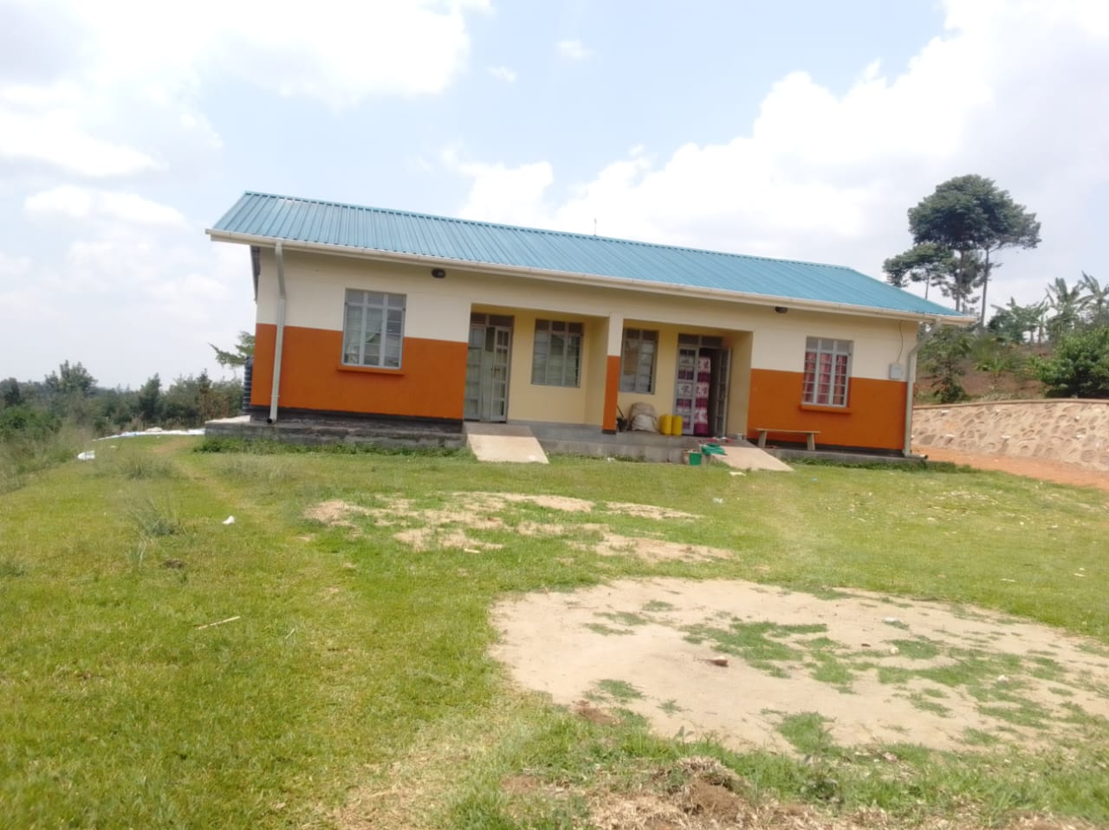  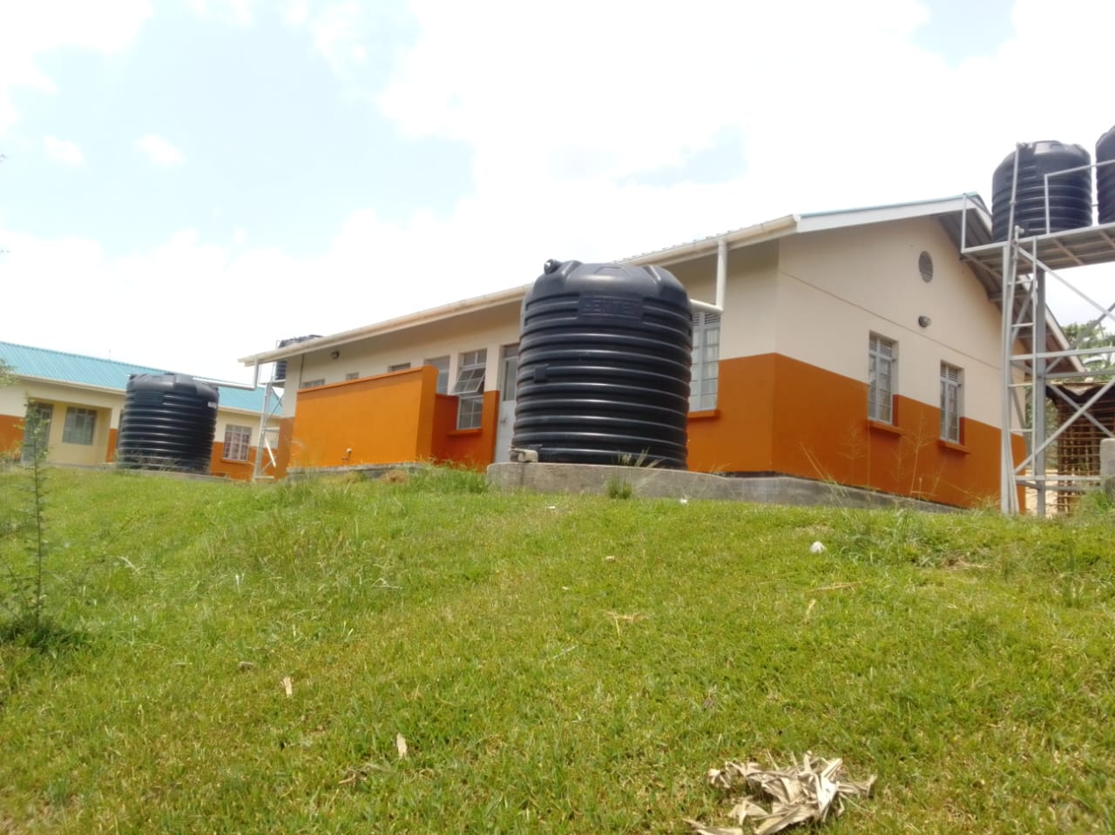  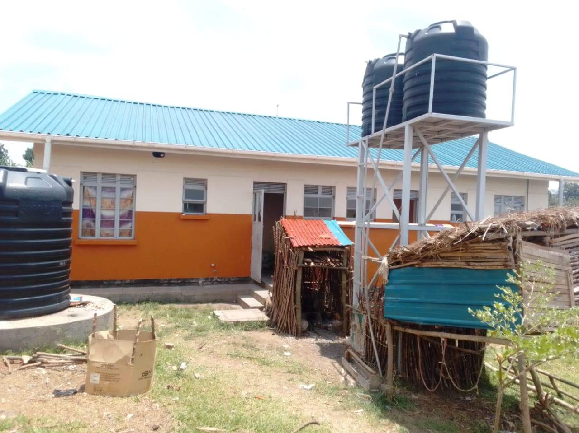
4 STANCE LINED PIT LATRINE | 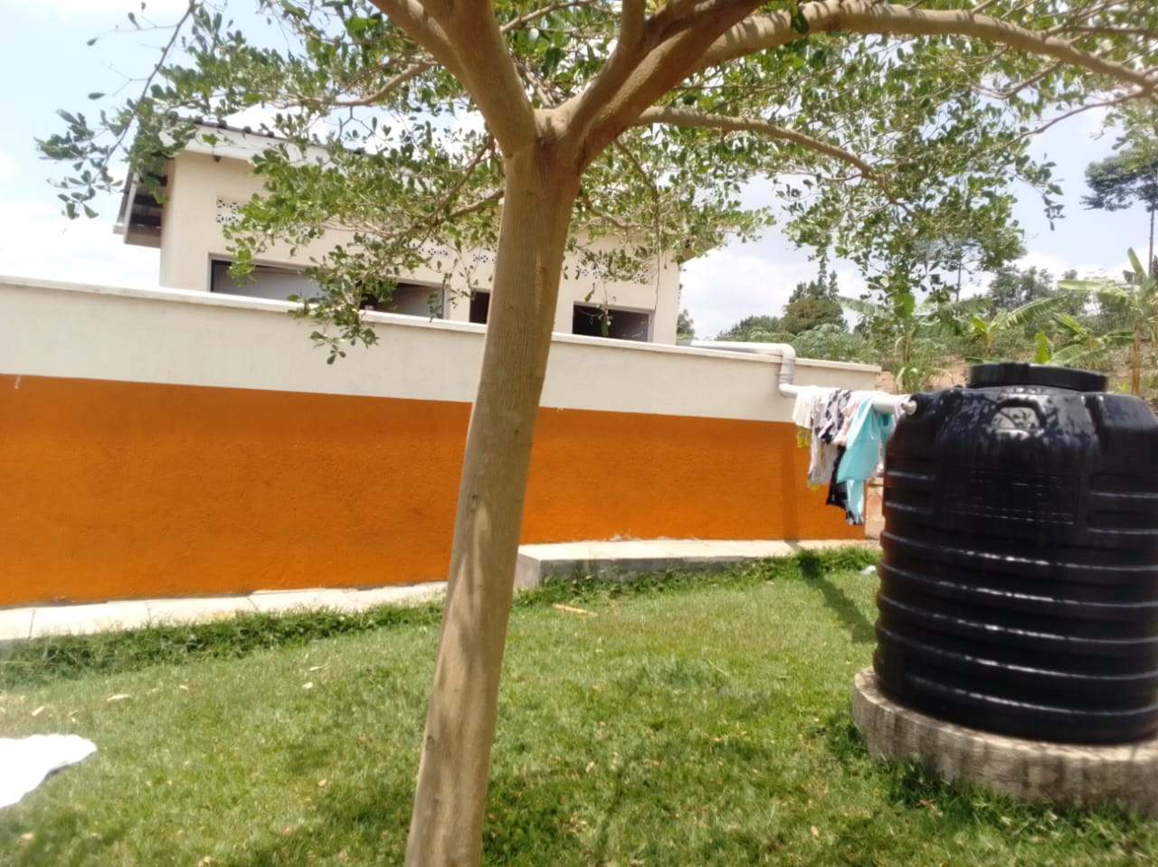  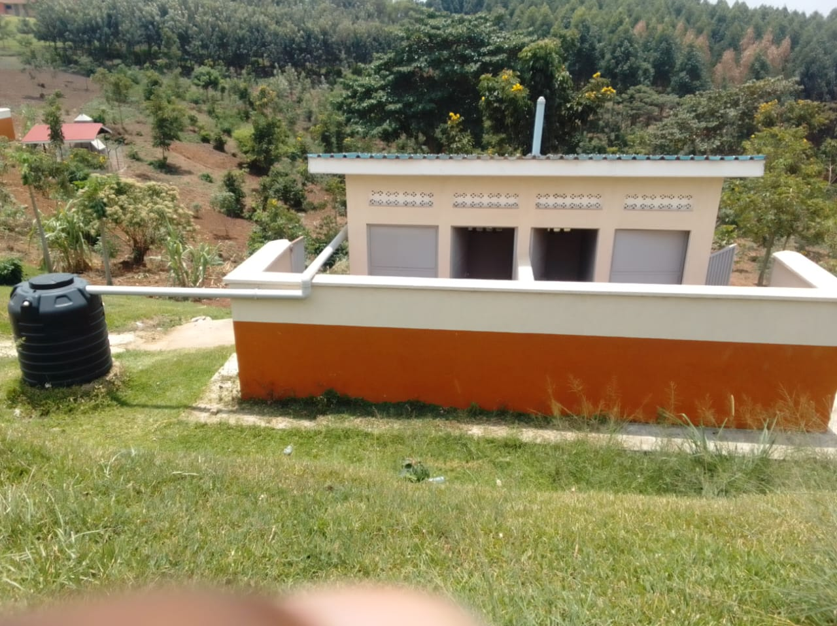  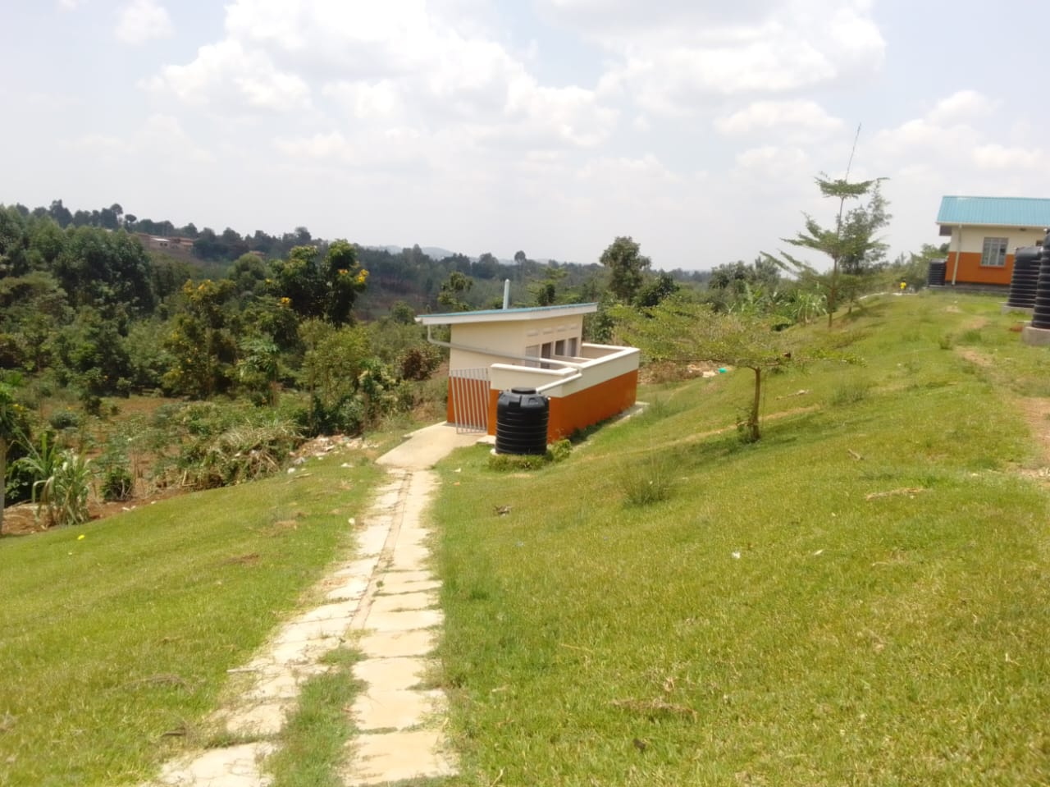  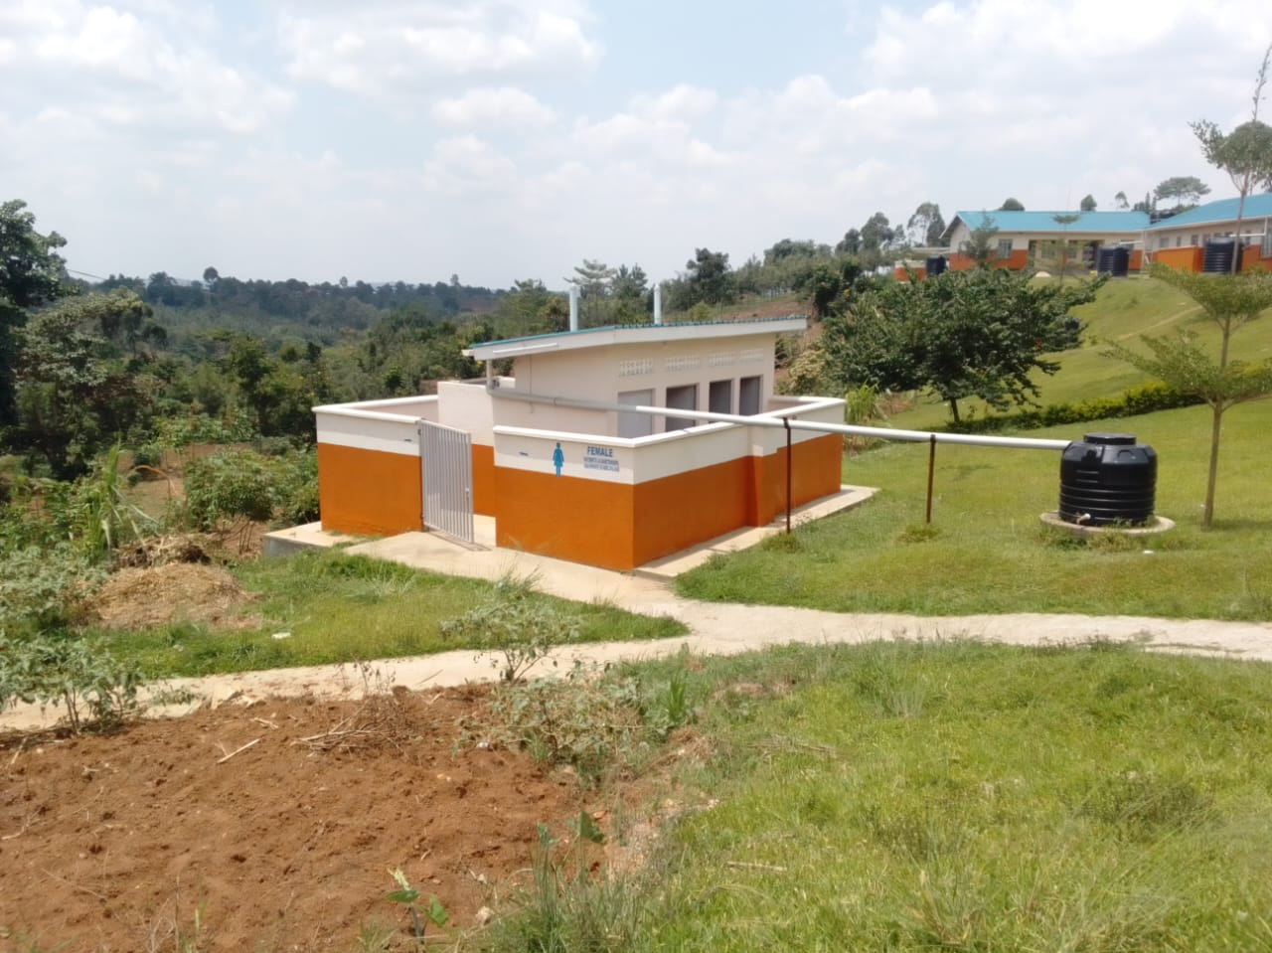  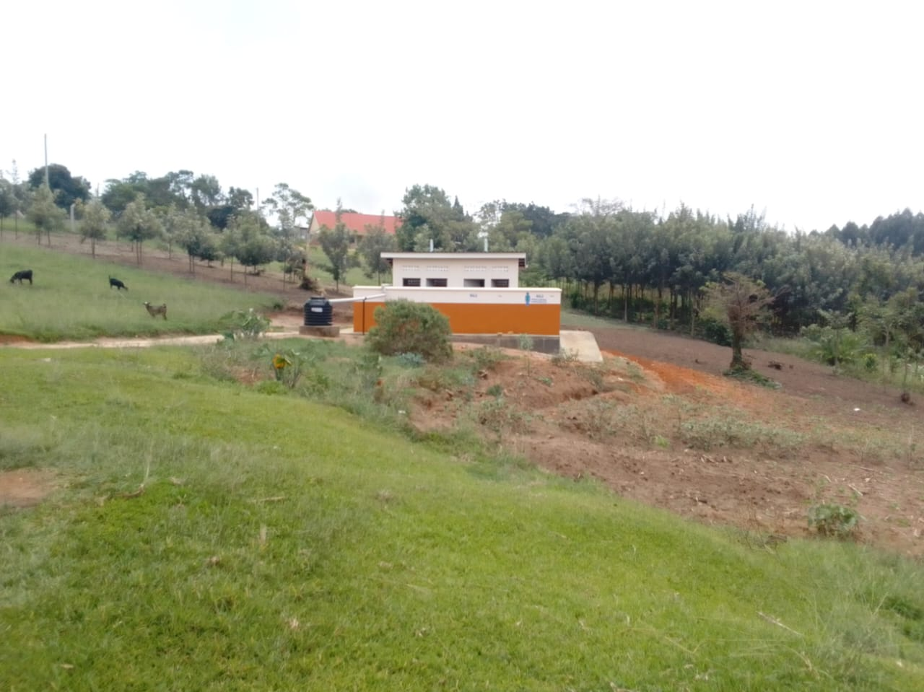
MATERNITY BUIL | 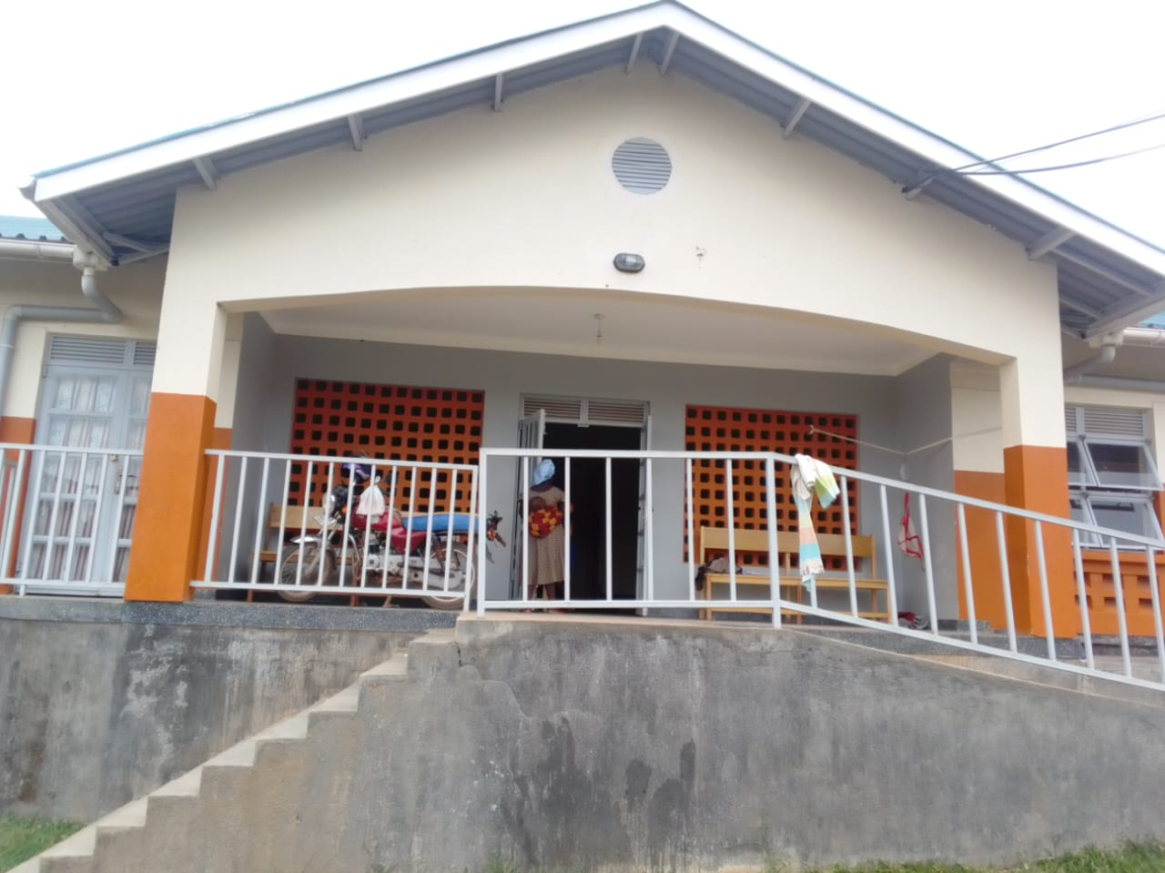
DING WITH A WASTE PIT AND A PLACENTA PIT | 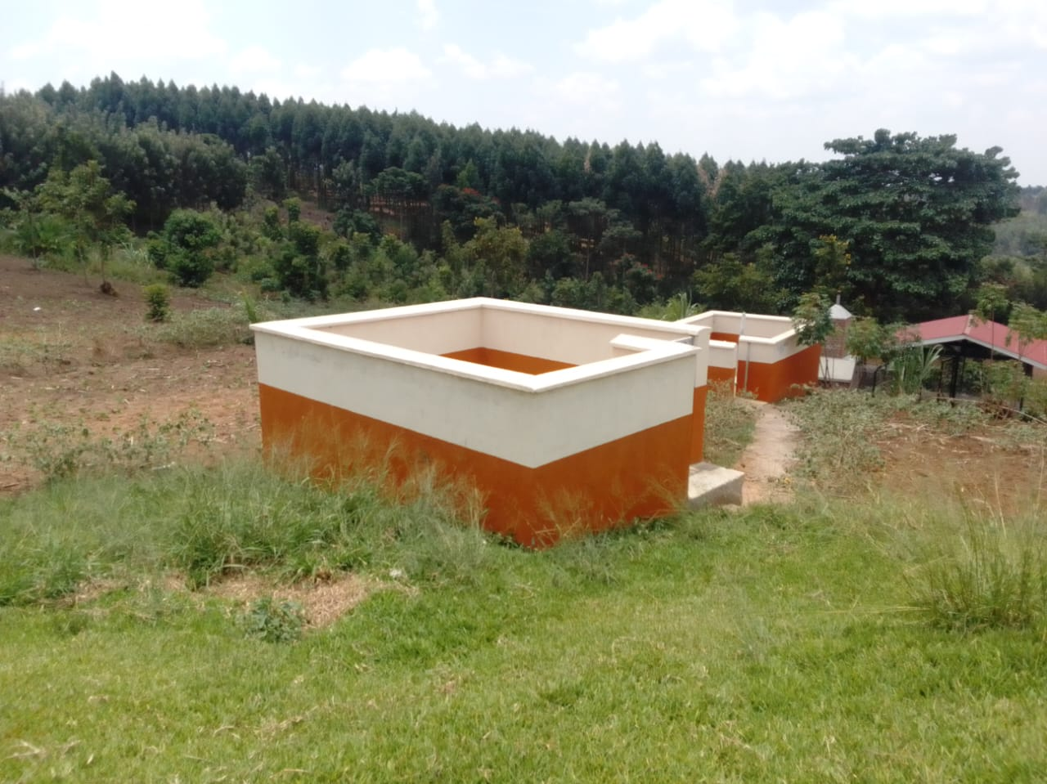
PACENTA PIT

A FENCED SOLAR HOUSE, WITH BATTERIES | 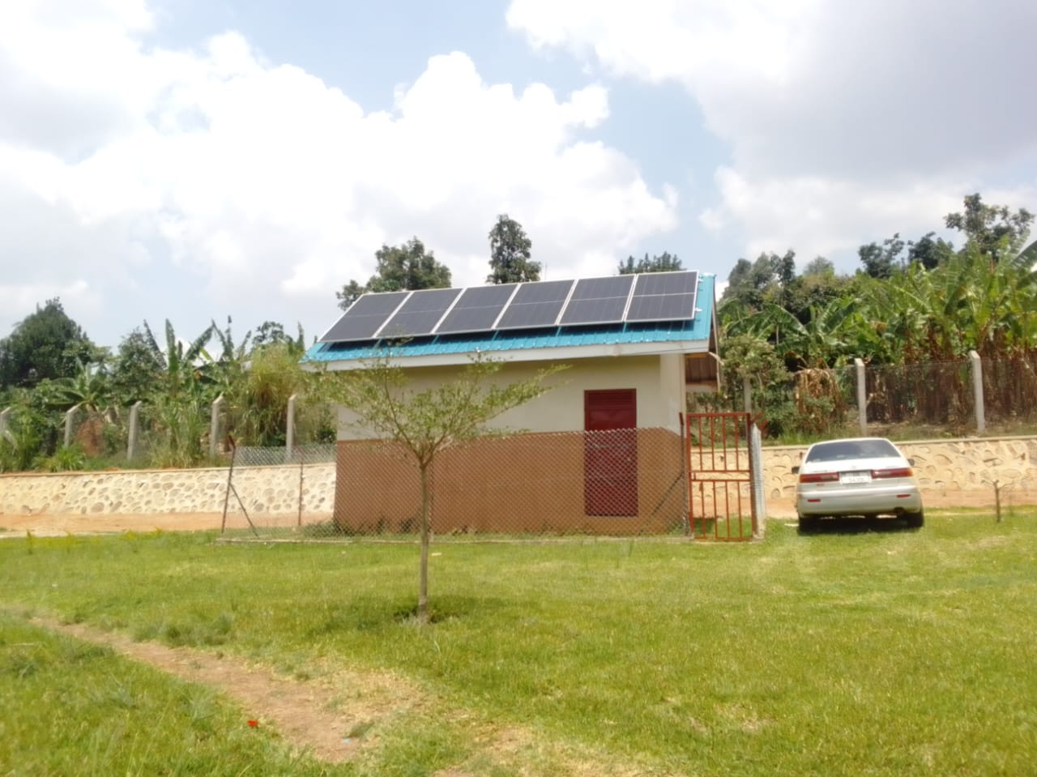
5,000LTRS HDPE CREST TANKS () WHICH FEEDS A 3,00OLTRS ELEVATED HDPE TANK WITH A PUMP | 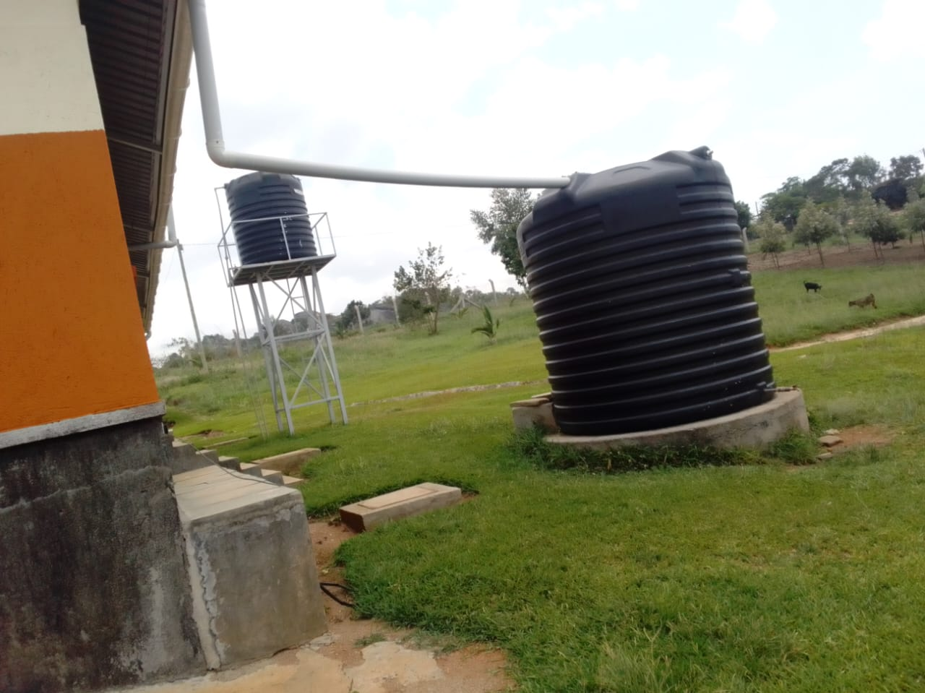
OPD BUILDING | 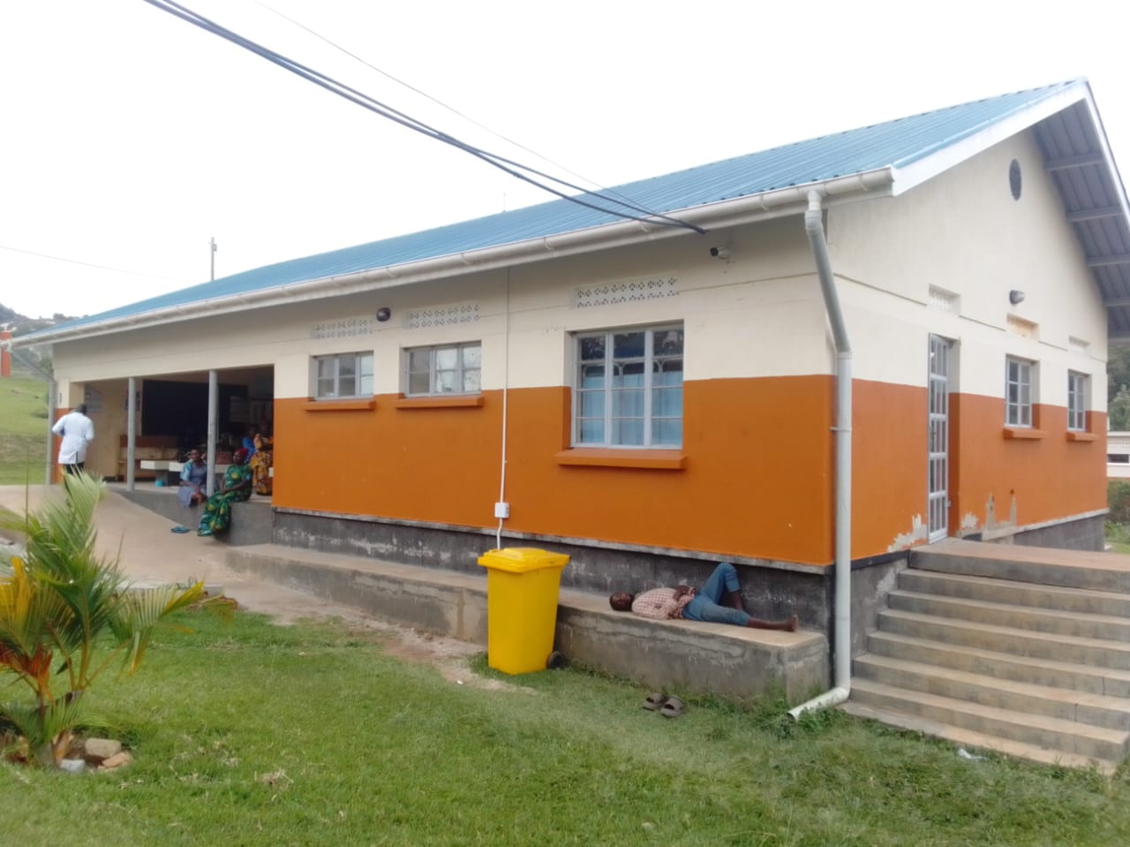
Fetal doppler | 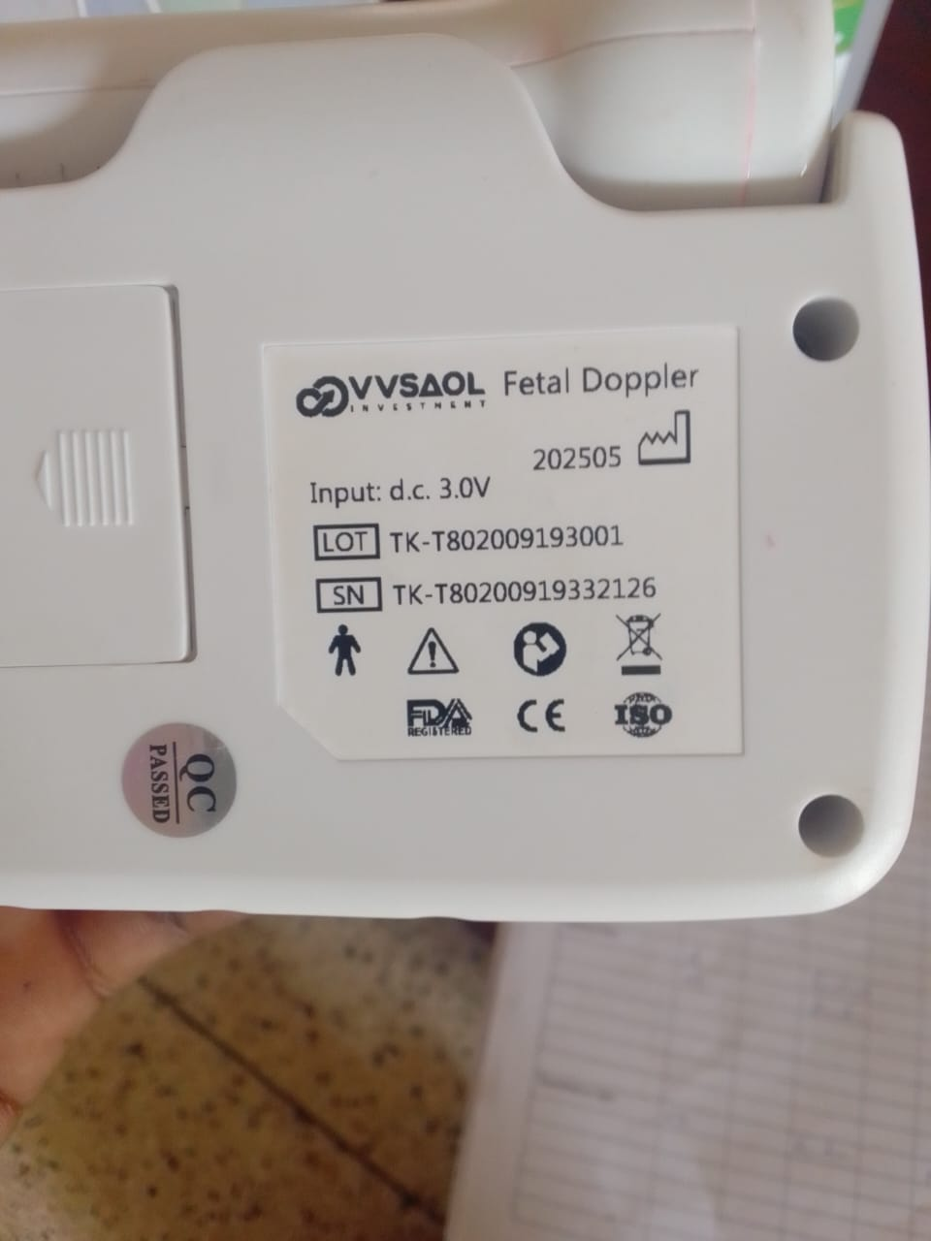
Disinfection bucket | 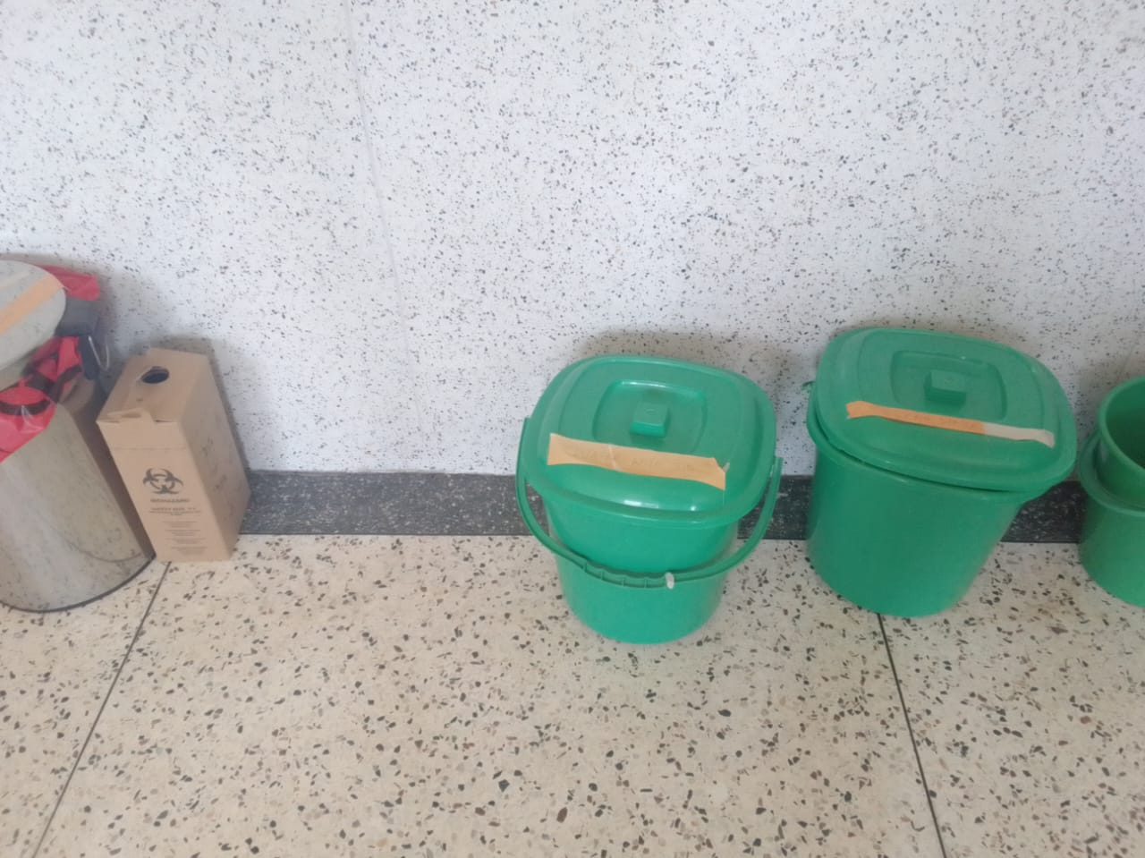
Radiant infant warmer | 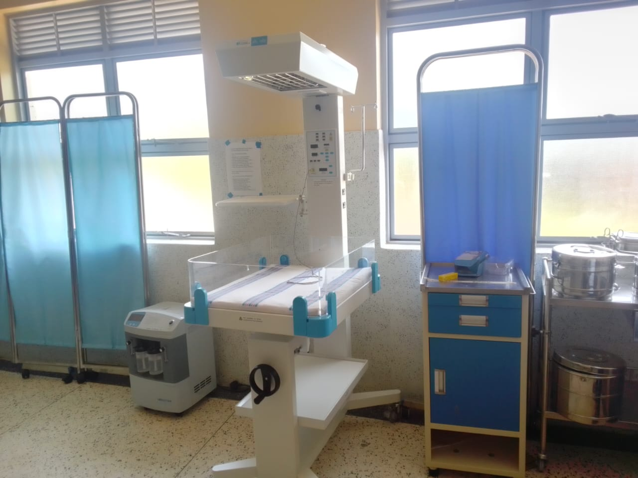
centrifuge | 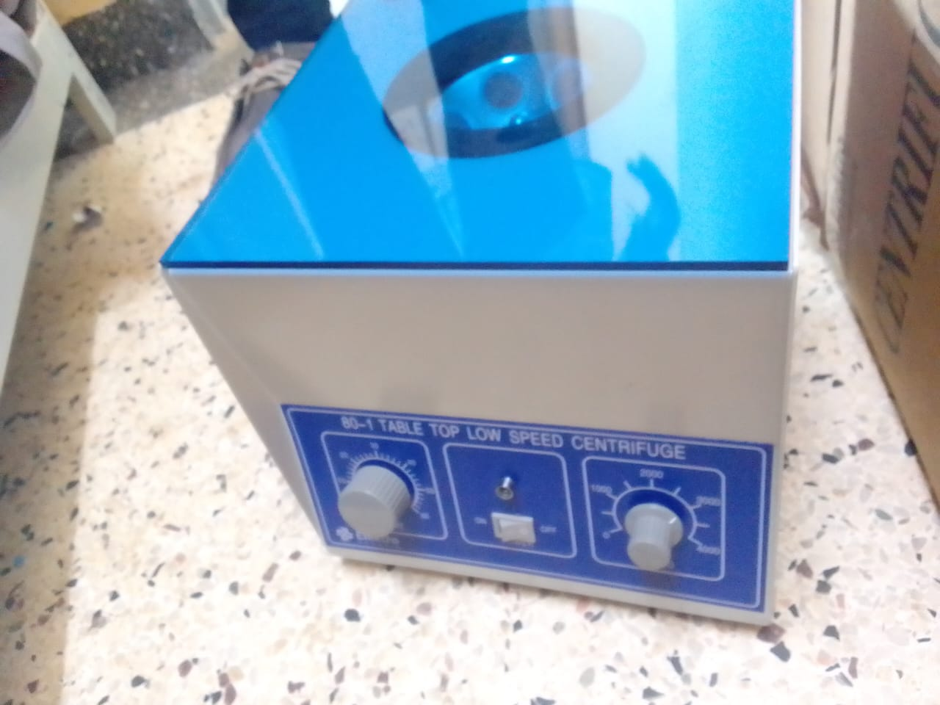
Microscope binocular | 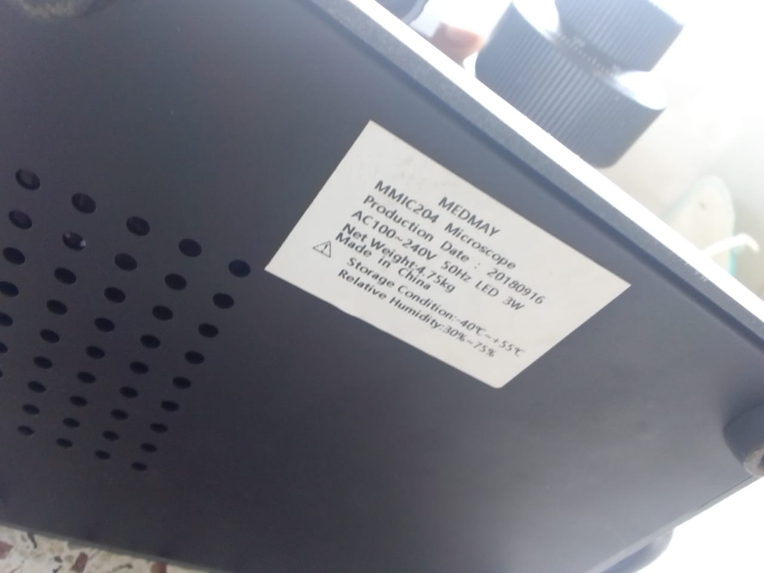
Examination couch, and patient screen | 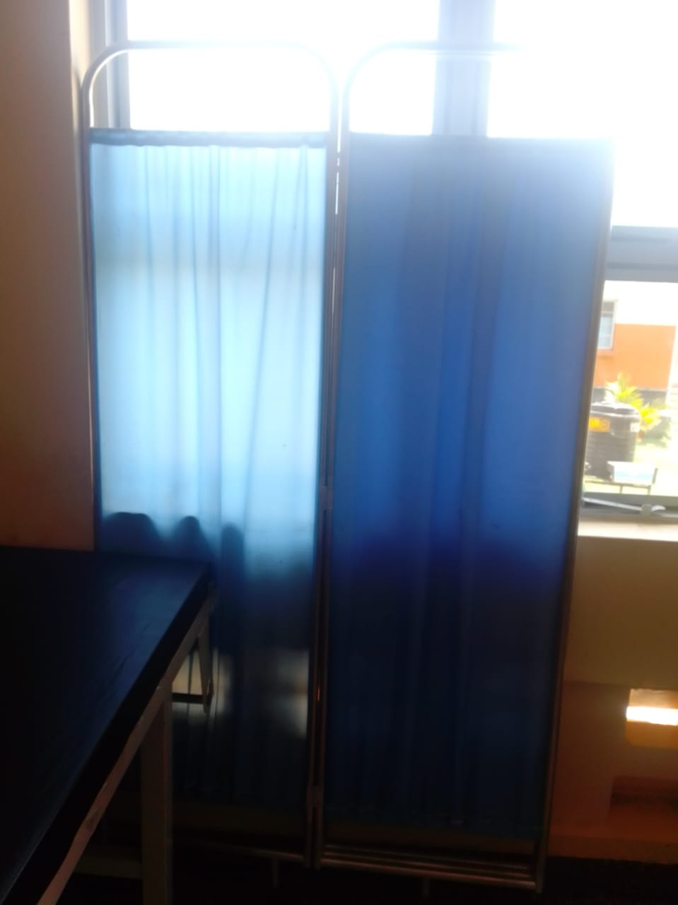
Delivery bed, hydraulic | 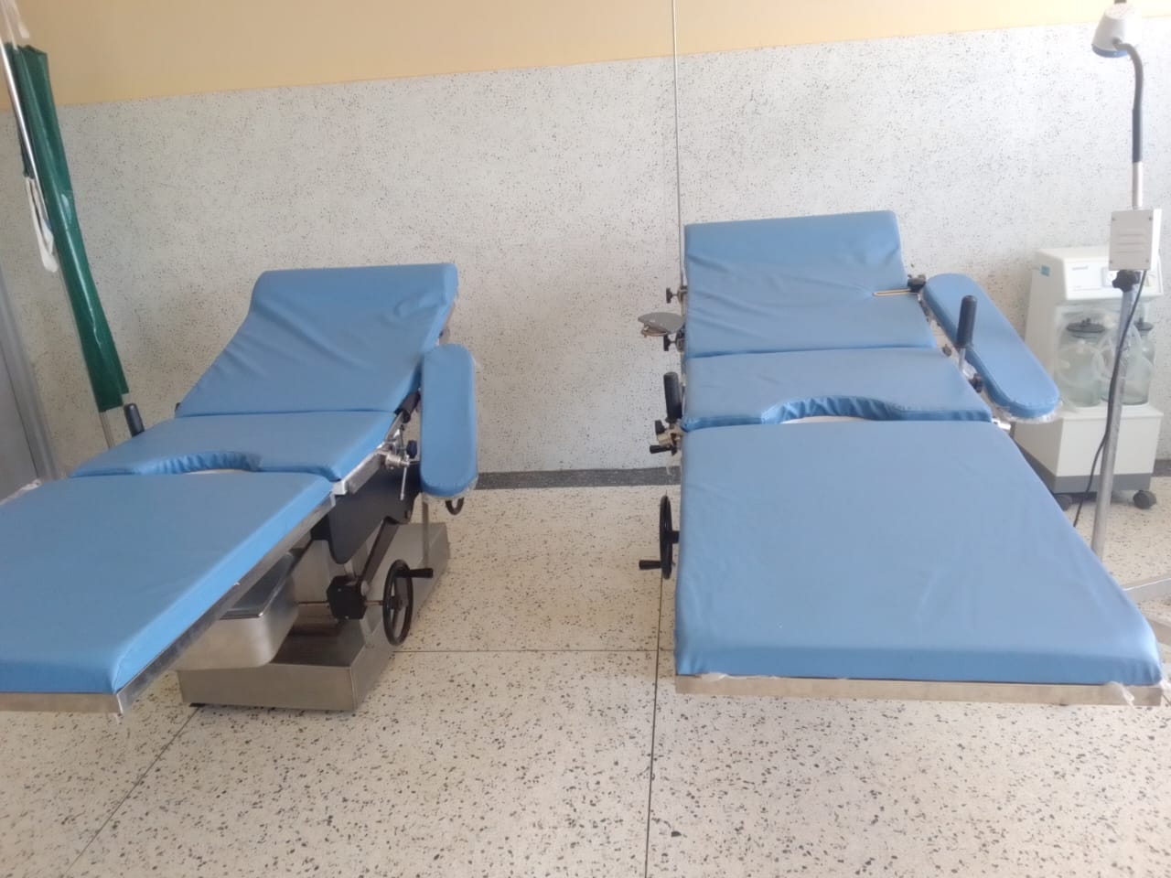
Delivery sets, MCH, with instrument trolley | 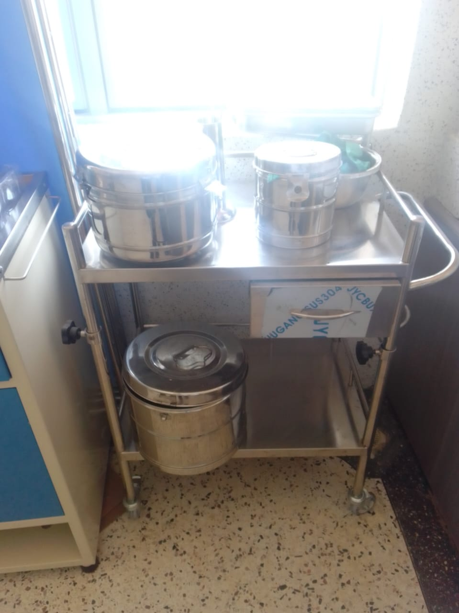
Baby cot | 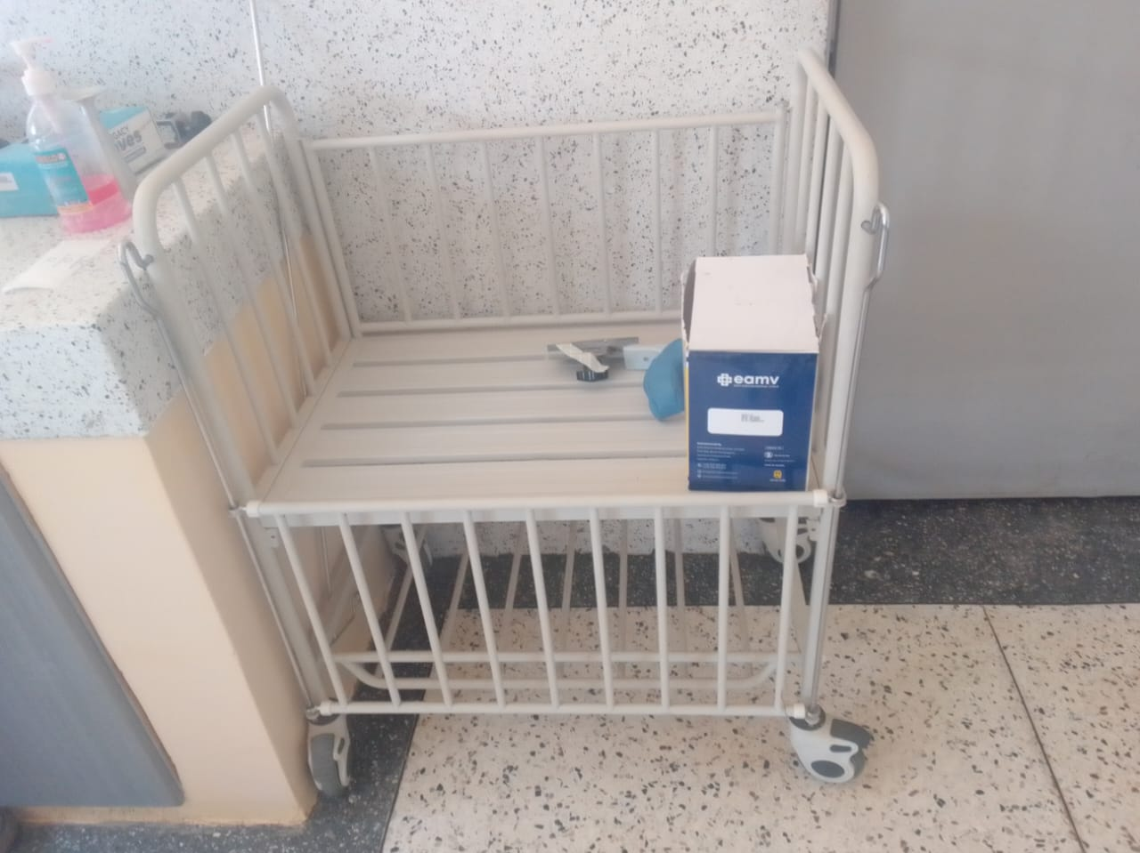
Bed side locker sample | 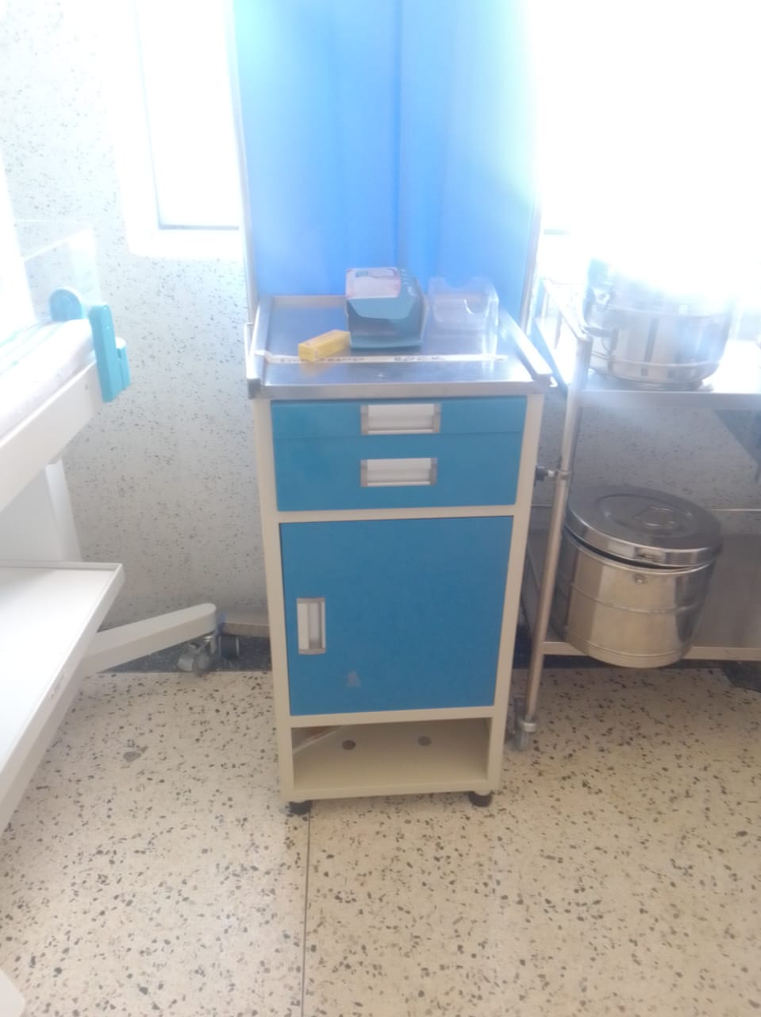
Sample of handheld pulse oximeter | 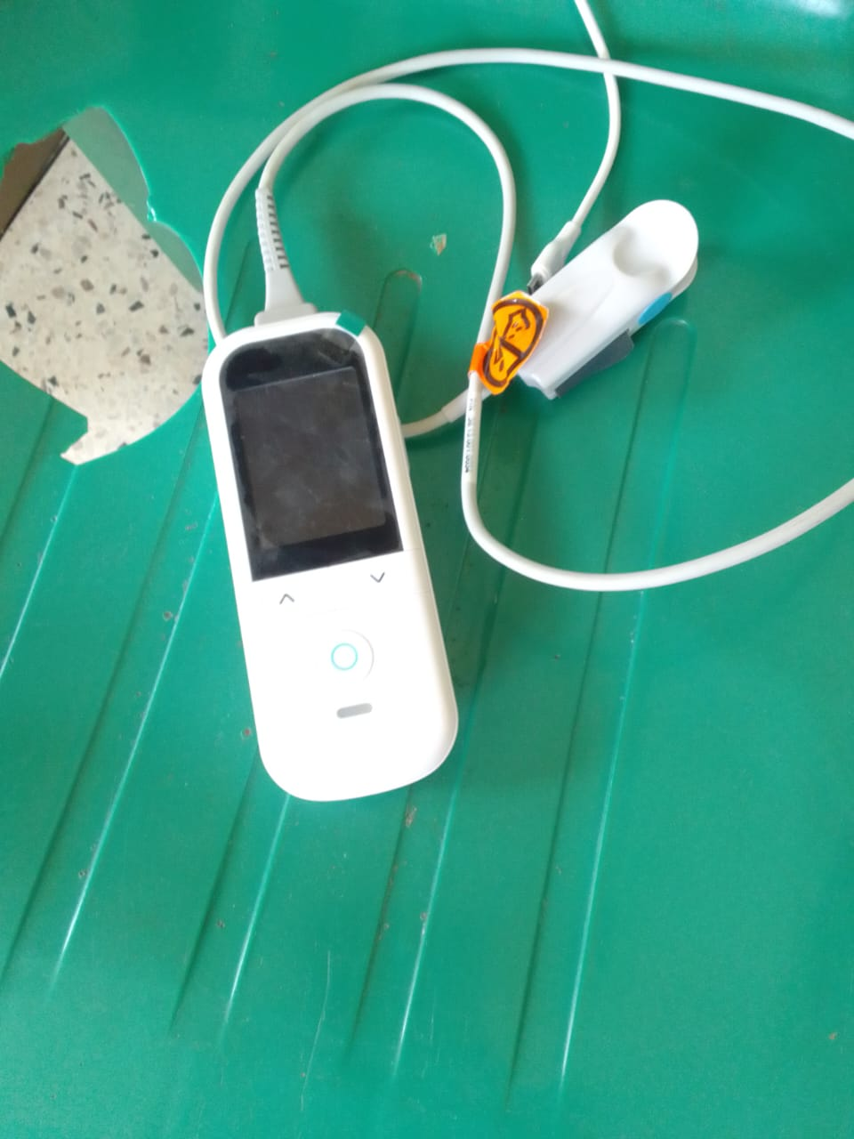
Audio Visio television | 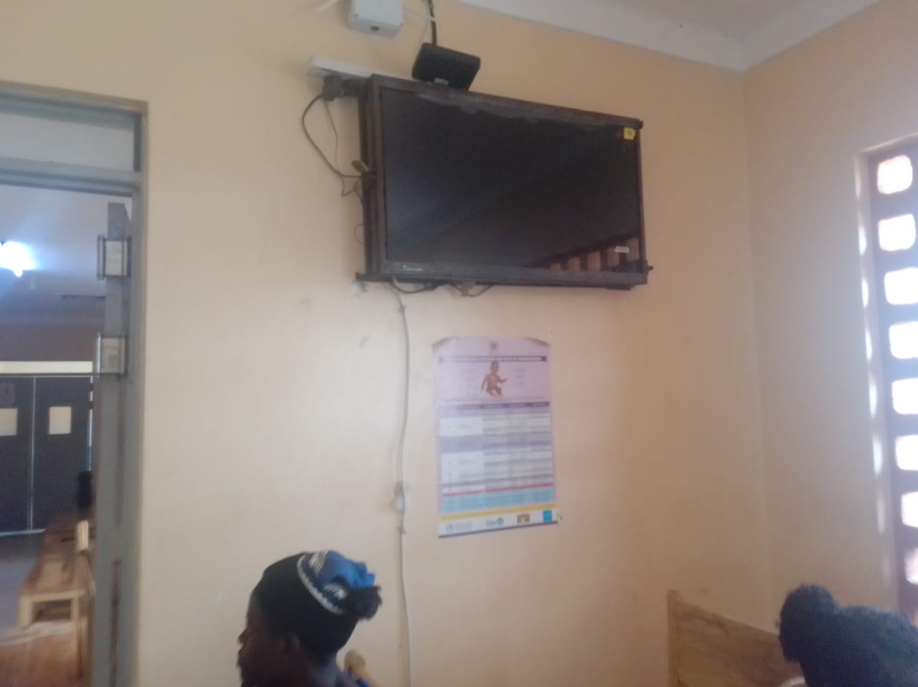
Weighing scale toddler, and other equipment packed in the store | 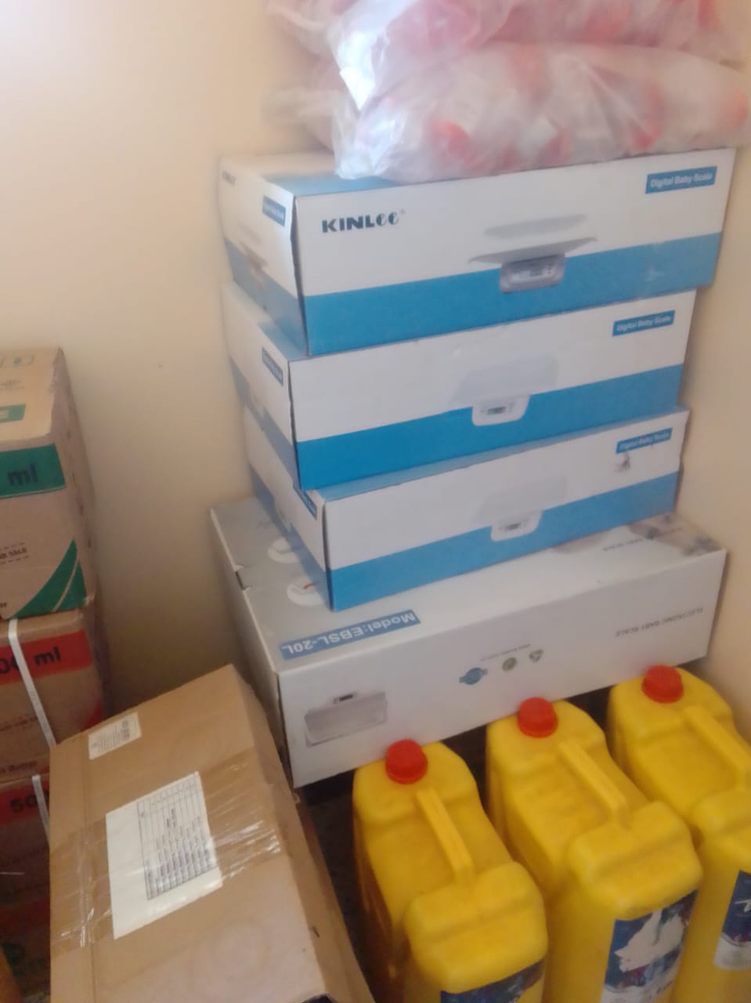
Sample of wighing scale, adult with a height meter | 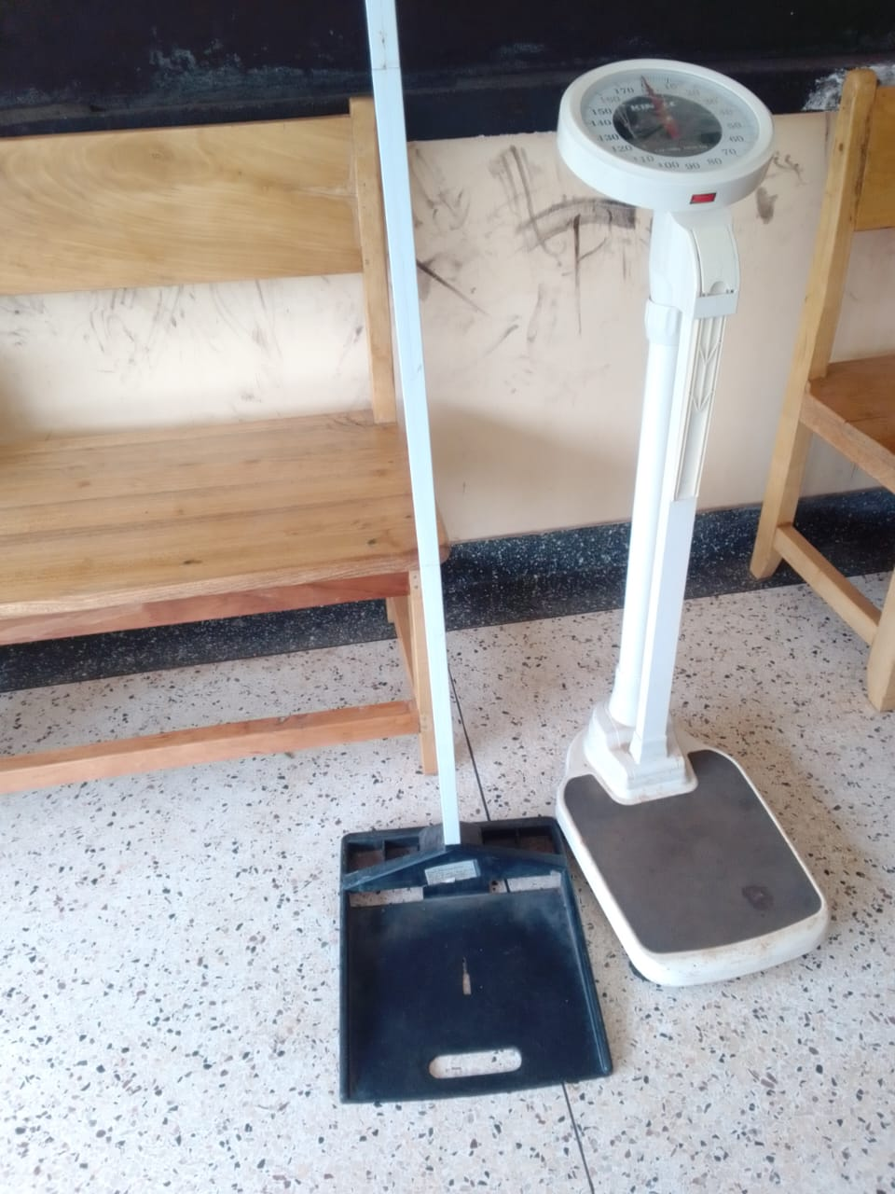
Sample of benches , not engraved | 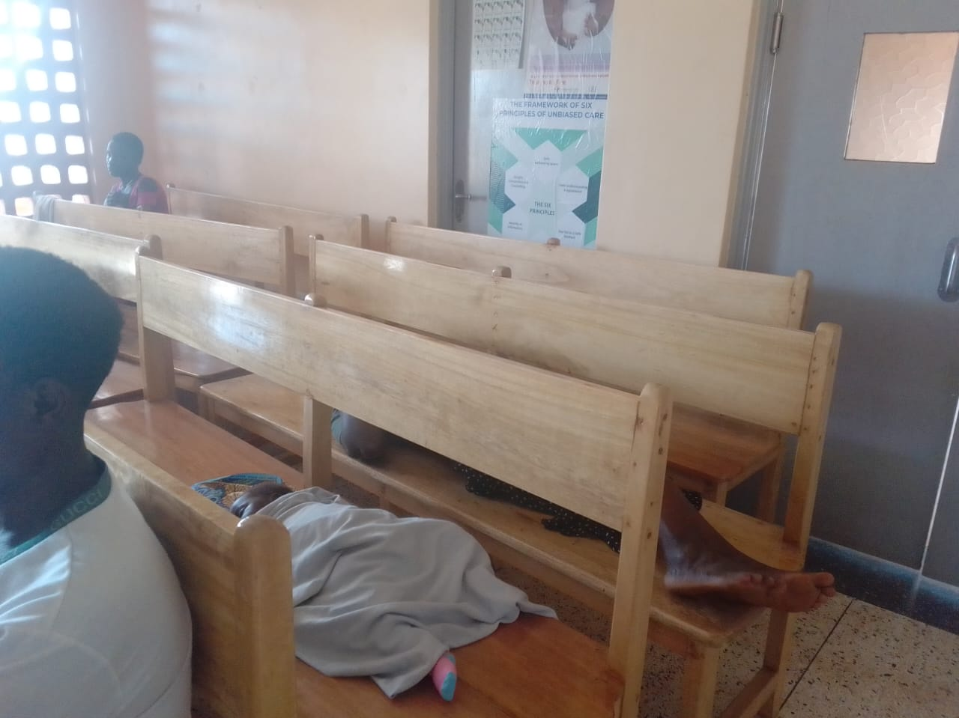
Sample of filling cabinet, with one broken | 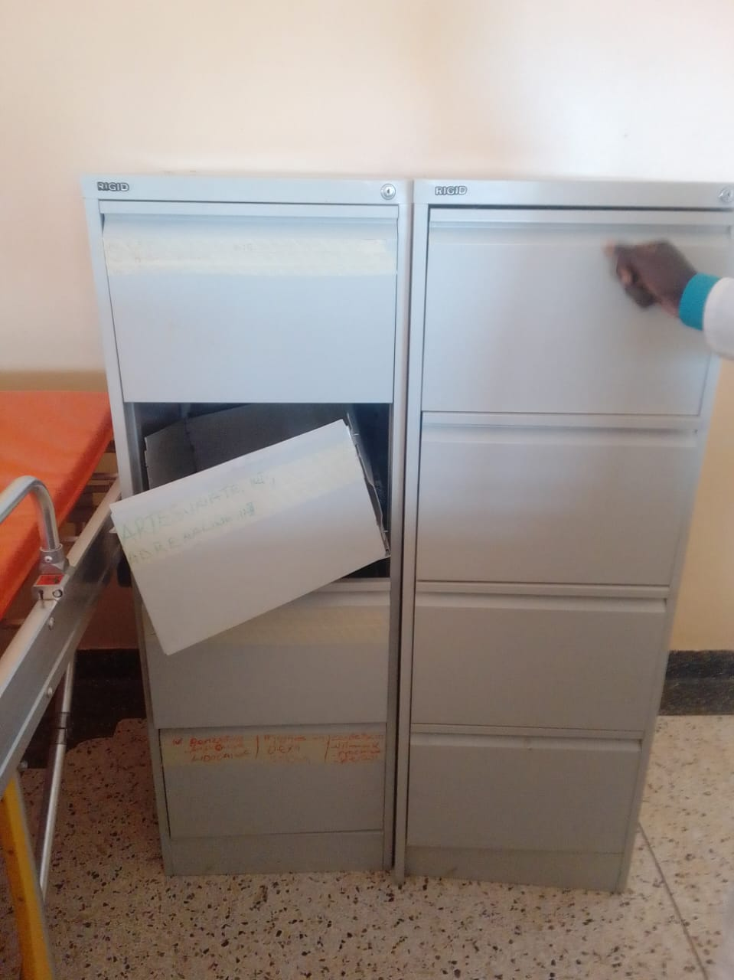
Instrument sets that were disorganized during delivery | 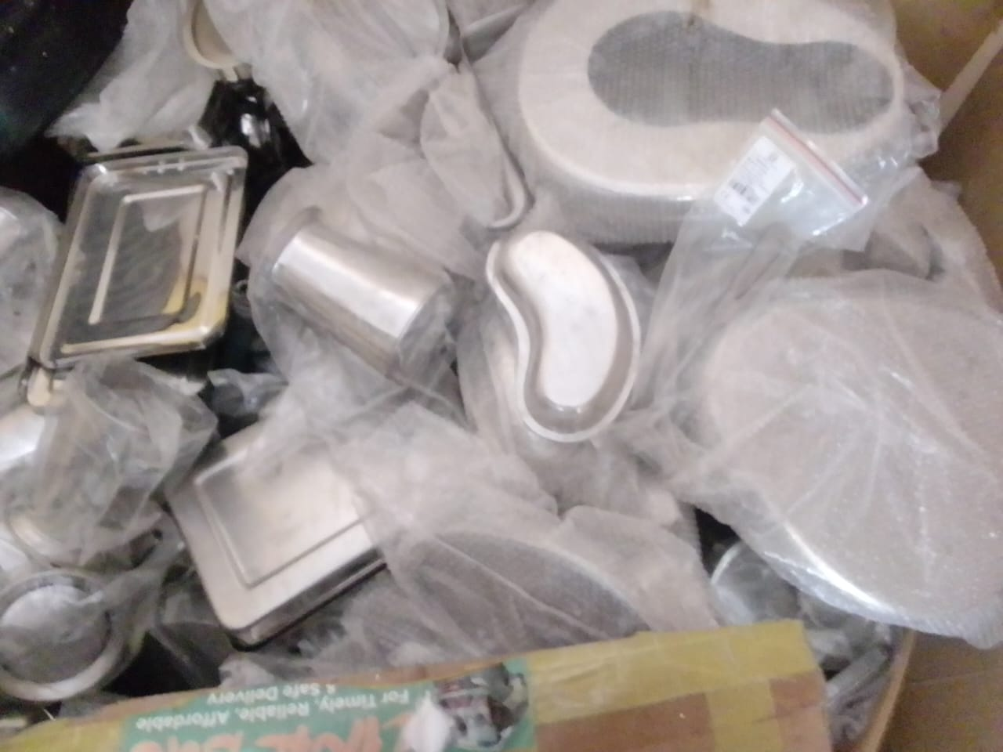
Sample of Stretcher, with drip stand | 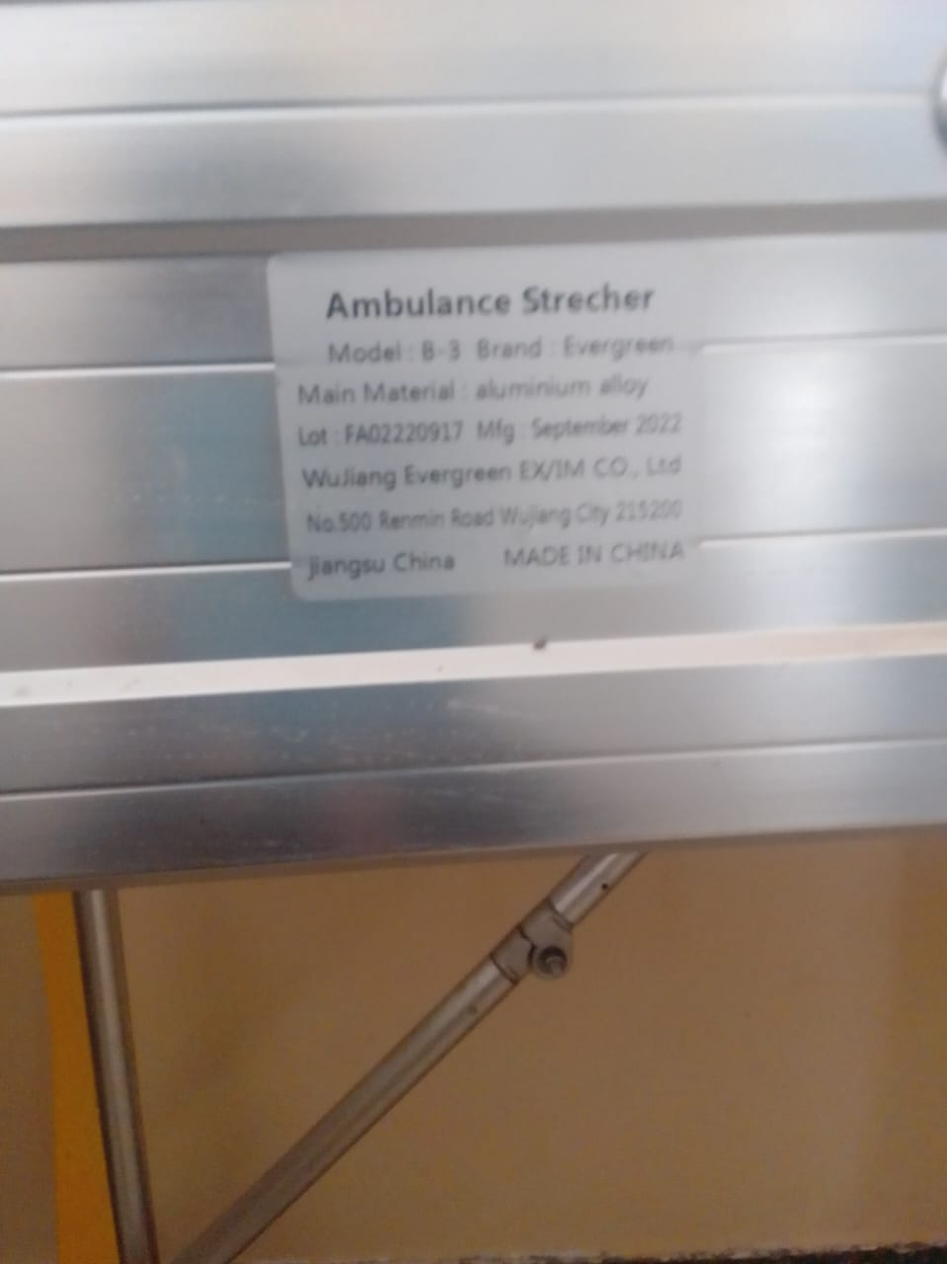
Sample of adult patient beds with drip stands, and bedsidelockers | 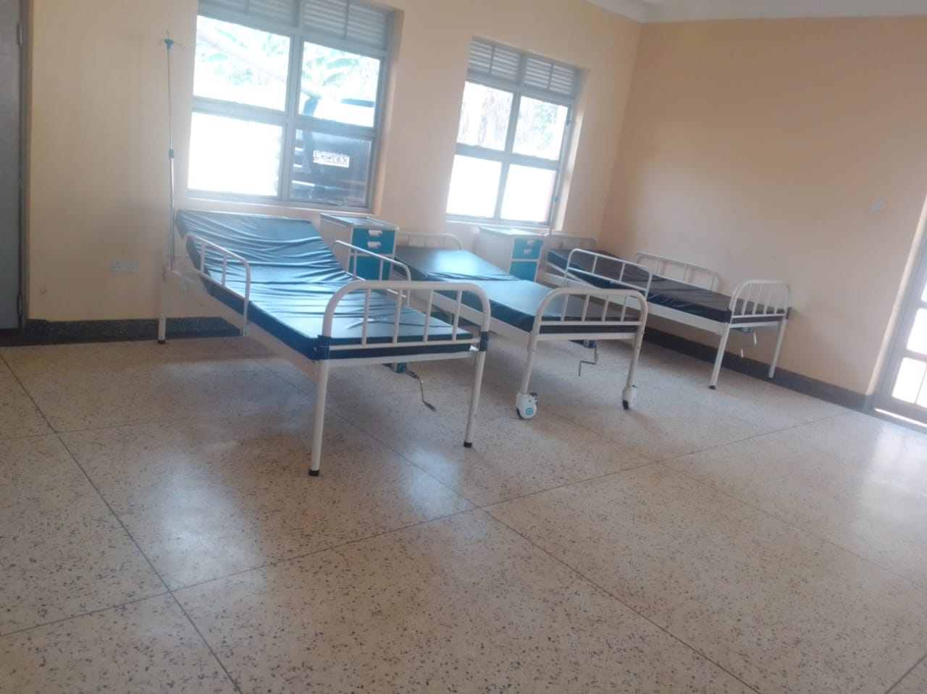
Sample of pedriatic beds with drip stands | 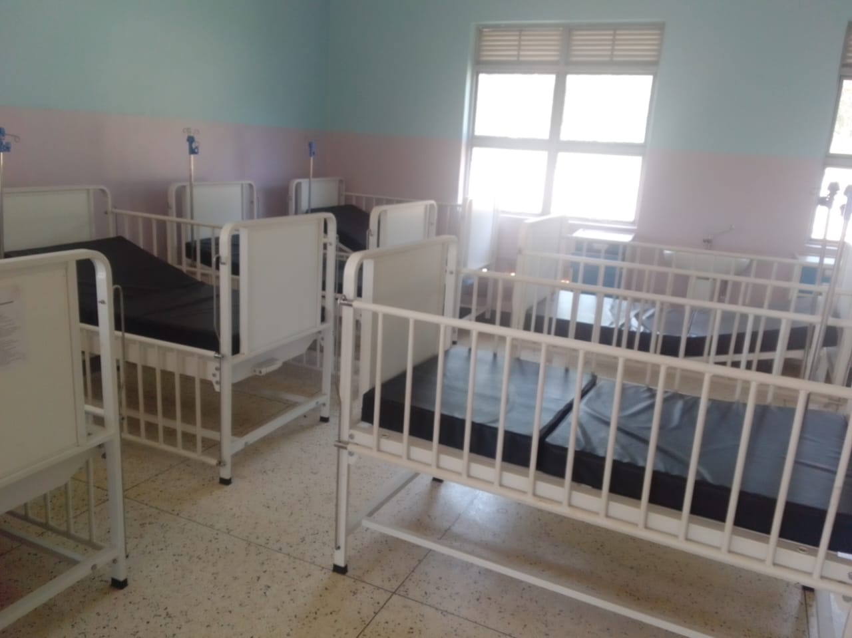
Sample of a wheelchair with a drip stand, however it was in a packed store | 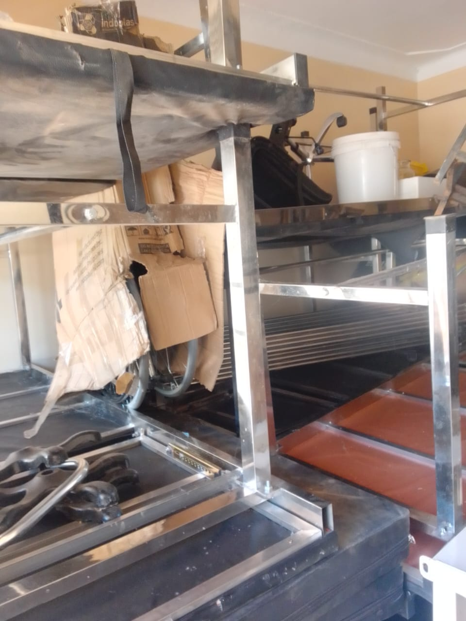
Sample of bowl stand | 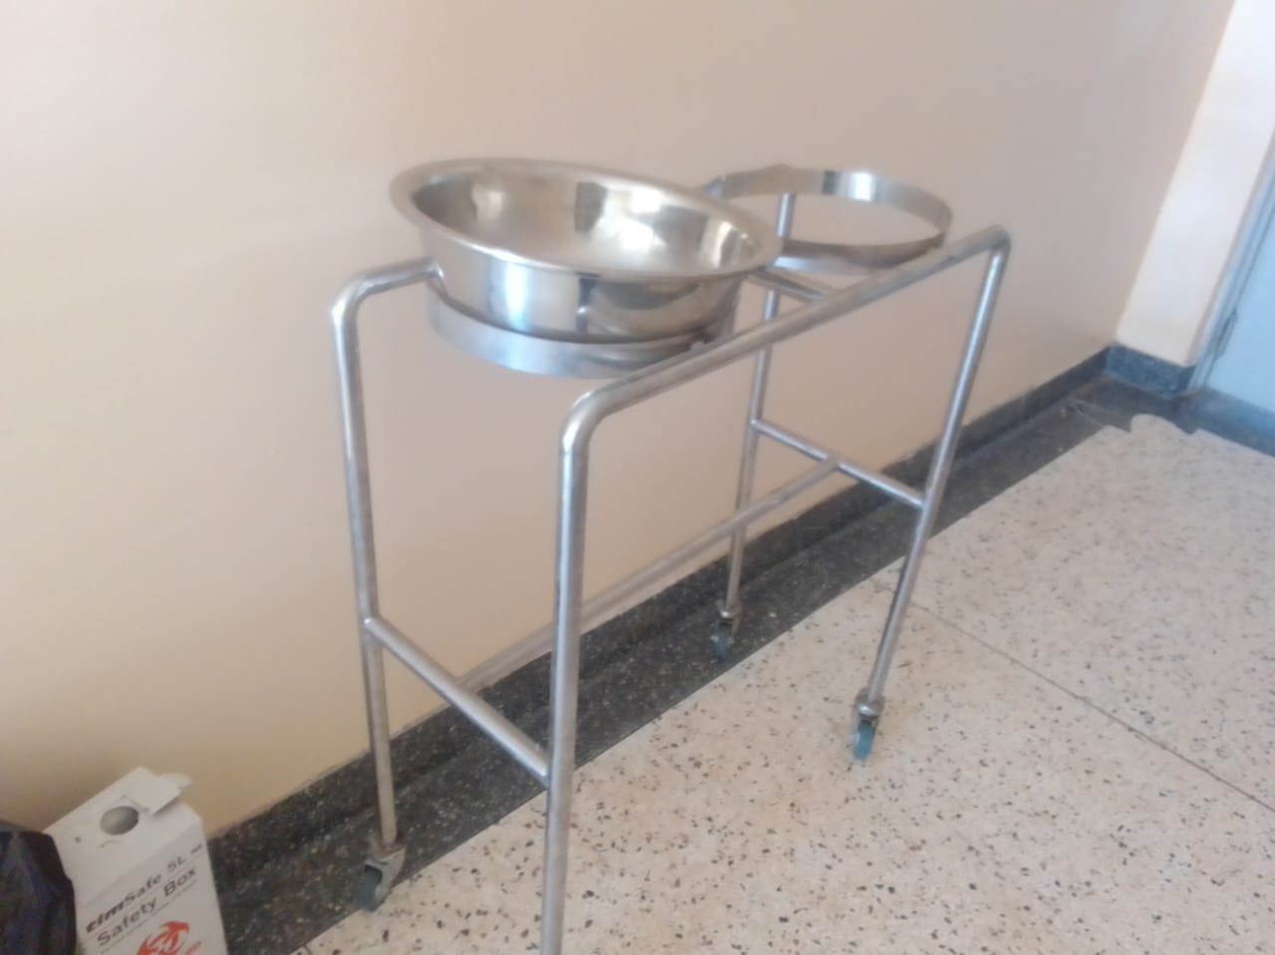
Oxygen therapy apparatus | 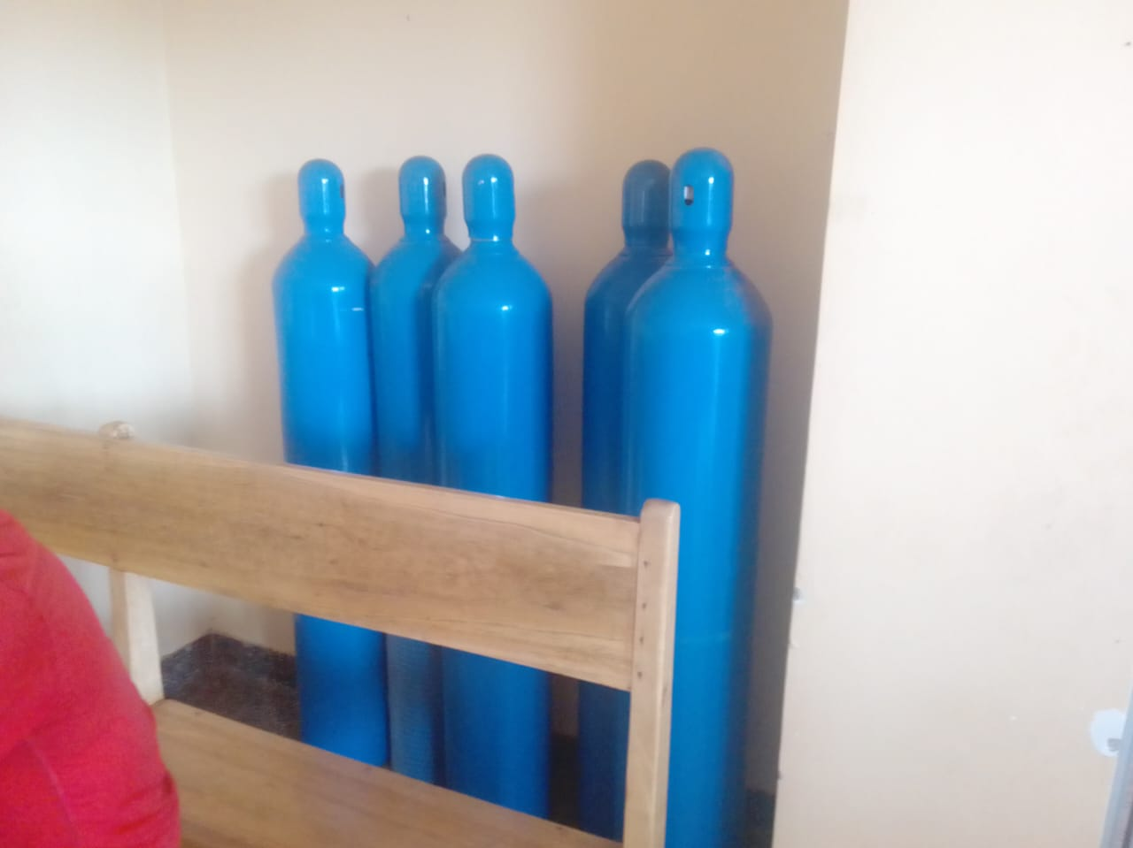
Sample of cupboards with glass | 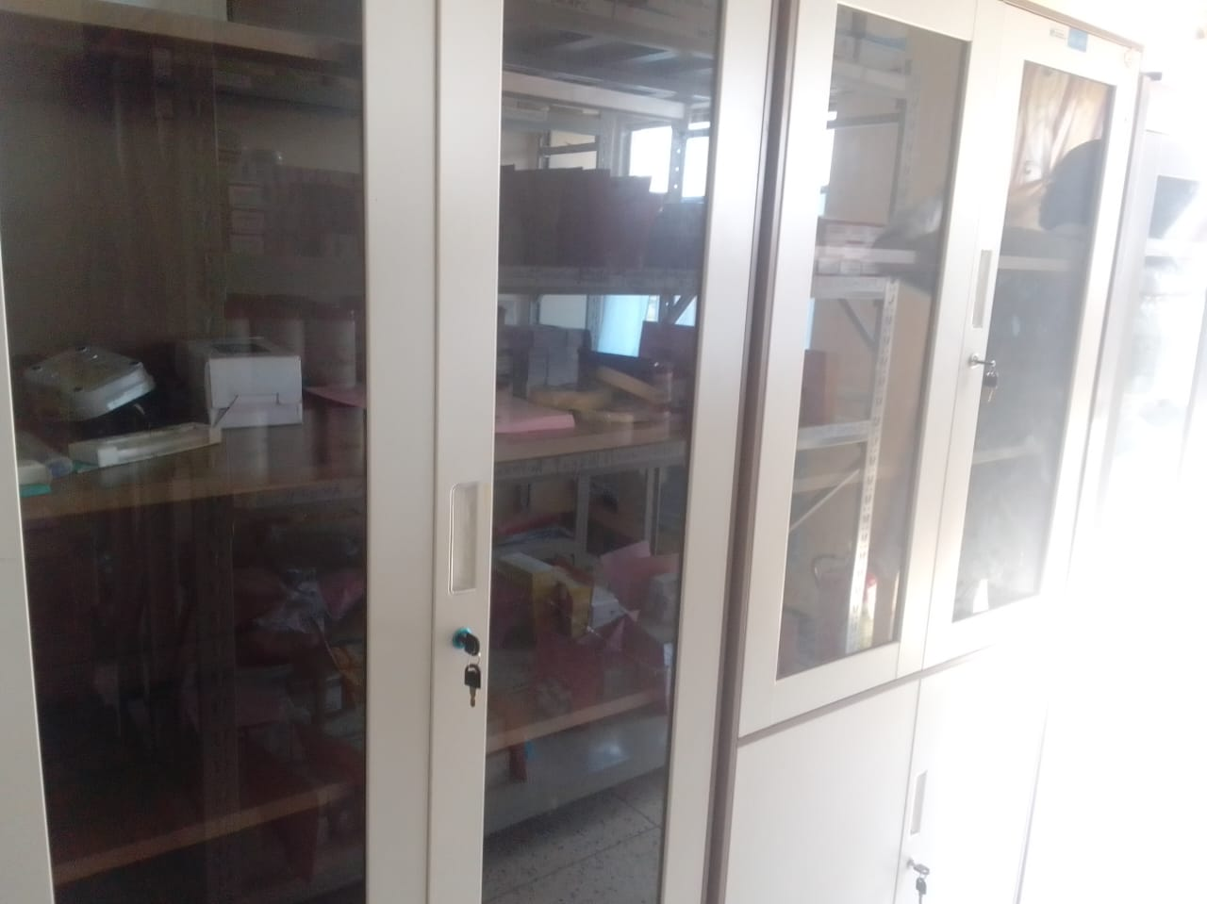
Sample of metallic stainless steel | 